|  |  |
| --- | --- |
| **­** | **MINISTRY OF EDUCATION AND TRAINING** |

**FPT UNIVERSITY**

|  |  |
| --- | --- |
| **Capstone Project Document** | |
| **Parking Guidance System Solution** | |
| **Group 1** | |
| **Group members** | Trần Nguyễn Minh Trung – Team Leader – SE61496  Bùi Phú Hiệp – Team Member – SE61438  Nguyễn Đỗ Phương Huy – Team Member – SE61358 |
| **Supervisor** | Nguyễn Đức Lợi |
| **Ext. Supervisor** | N/A |
| **Capstone Project Code** | PGSS |

- Ho Chi Minh City, Jan, 2017

*This page is intentionally left blank*

# Table of Contents

Table of Contents 2

List of Tables 7

List of Figures 9

Definitions, Acronyms and Abbreviations 13

A. Introduction 14

1. Project Information 14

2. Introduction 14

3. Current Situation 14

3.1. Indoor parking area 15

3.2. Outdoor parking area 16

3.3. Traditional PGS 17

4. Problem Definition 18

5. Proposed Solution 19

5.1. Feature functions 19

5.1.1. Parking Guidance System 19

5.1.2. Mobile app 19

5.2. Advantages 19

5.3. Disadvantages 19

6. Functional Requirements 20

7. Roles and Responsibilities 20

8. Conclusion 21

B. Software – Hardware Project Management Plan 22

1. Problem Definition 22

1.1. Name of this Capstone Project 22

1.2. Problem Abstract 22

1.3. Project Overview 22

1.3.1. Current Situation 22

1.3.2. The Proposed System 22

1.3.2.1. Interaction Block 23

1.3.2.2. Information Block 23

1.3.2.3. Central Control Unit 23

1.3.2.4. Web API Server 23

1.3.2.5. Mobile Application 23

1.3.3. Boundaries of the System 23

1.3.4. Future Plans 24

1.3.5. Development Environment 25

1.3.5.1. Hardware requirements 25

1.3.5.2. Software requirements 26

2. Project organization 26

2.1. Software Process Model 26

2.2. Roles and responsibilities 27

2.3. Tools and Techniques 28

3. Project Management Plan 29

4. Coding Convention 29

C. Software – Hardware Requirement Specification 30

1. Software Requirement Specification 30

1.1. Software Requirement 30

1.2. GUI Requirement 30

2. Hardware Requirement Specification 30

2.1. Hardware Requirement 30

2.1.1. Hardware Interface 30

2.1.1.1. Block Diagram 31

2.1.1.2. Raspberry Pi 3 32

2.1.1.3. Arduino Nano 33

2.1.1.4. Compass Module 3-Axis HMC5883L 34

2.1.1.5. RF module nRF24L01+ 36

2.1.1.6. Information LED Display Module 37

2.1.1.7. Indicator LED Module 41

2.1.1.8. Servo Motor SG90 45

2.1.2. Communication Protocol 46

2.2. System Overview Use Case 46

2.3. List of Use Case 47

2.3.1. Manager Use Case 47

2.3.2. Administrator Use Case 51

2.3.3. End User Use Case 60

3. Software System Attribute 64

3.1. Usability 64

3.2. Reliability 64

3.3. Availability 64

3.4. Security 64

3.5. Maintainability 64

3.6. Portability 65

3.7. Performance 65

4. Conceptual Diagram 65

D. Software – Hardware Design Description 66

1. Design Overview 66

2. System Architectural Design 67

2.1. Hardware Program Architecture Description 68

2.2. Mobile Application Architecture Description 70

2.3. Web API Architecture Description 71

3. Component Diagram 72

3.1. General Component Diagram 72

3.2. Lot Device Diagram 73

3.3. Information Device Diagram 73

3.4. Server Diagram 74

3.5. Component Dictionary 74

4. Detailed Description 75

4.1. Web API Detailed Description 75

4.1.1. Class Diagram 75

4.1.2. Class Diagram Explanation 80

4.1.3. Interaction Diagram 80

4.1.3.1. Register 81

4.1.3.2. Login 82

4.1.3.3. Get Car Park 82

4.1.3.4. Get Area 83

4.1.3.5. Get Parking Lot 83

4.1.3.6. Update Area 84

4.1.3.7. Update Parking Lot 84

4.1.3.8. Update List Status Parking Lot 85

4.2. Mobile Detailed Description 85

4.2.1. Class Diagram 85

4.2.2. Class Diagram Explanation 96

4.2.3. Interaction Diagram 96

4.2.3.1. Load car parks on map 96

4.2.3.2. Load car parks in list 97

4.2.3.3. Car park detail information 98

4.2.3.4. Reserve parking lot process 99

4.2.3.5. Transaction controller 100

4.2.3.6. Manage car parks 102

4.2.3.7. Manage areas 103

4.2.3.8. Manage parking lots 104

4.2.3.9. Check reservation PIN code 105

4.3. Embedded Program Detailed Description 106

4.3.1. Class Diagram 106

4.3.2. Class Diagram Explanation 109

4.3.3. Interaction Diagram 109

4.3.3.1. Lot node process 109

4.3.3.2. Sign node process 111

4.3.3.3. Hub polling process 112

4.3.3.1. Hub execute request process 114

4.4. Hardware Detailed Description 116

4.4.1. Raspberry Pi 3 model B 116

4.4.2. Arduino Nano 118

4.4.3. Compass module 3-Axis HMC5883L 120

4.4.4. RF module nRF24L01+ 123

4.4.5. Lot node 128

4.4.5.1. RGB LED common anode 128

4.4.5.2. Transistor TIP122 130

4.4.5.3. Servo motor SG90 131

4.4.5.4. LM7805 133

4.4.6. Sign node 134

4.4.6.1. Power logic 8-bit shift register TPIC6B595 134

4.4.6.2. 7-Segment LED display 137

4.4.7. Components connection 138

4.4.7.1. Overview component connection 138

4.4.7.2. Raspberry Pi 3 connection 140

4.4.7.3. Lot node connection 140

4.4.7.4. Sign node connection 140

5. Interface 141

6. Database Design 141

6.1. Logical Diagram 141

6.2. Data Dictionary 141

7. Algorithms 143

7.1. GetDistance formula 143

7.2. CRC Error Detection 143

7.2.1. Definition 143

7.2.2. Define Problem 144

7.2.3. Solution theory 144

7.2.4. Implementation 146

7.2.5. Table-driven implementation 147

E. System Implementation & Test 151

F. User’s Manual 151

G. Appendix 151

# List of Tables

Table 1: Definitions, Acronyms and Abbreviations 13

Table 2: Roles and Responsibilities 20

Table 3: Database requirement 25

Table 4: API Service Requirement 25

Table 5: Provide CCU Hardware 25

Table 6: Roles and Responsibilities Details 28

Table 7: Tools 28

Table 8: Techniques 29

Table 9: Raspberry Pi 3 – Specification 32

Table 10: Arduino Nano - Specification 34

Table 11: The Compass Module 3-Axis HMC5883L - Pin Function 35

Table 12: RF Module nRF24L01 – Pin function 37

Table 13: IC TPIC6B595 - Pin Function 41

Table 14: Servo Motor SG90 – Pin-outs 46

Table 15: Conceptual diagram data dictionary 65

Table 16: Component dictionary 75

Table 17: Packages dictionary 85

Table 18: Activities package class dictionary 87

Table 19: Adapters package class dictionary 90

Table 20: Helpers package class dictionary 90

Table 21: Interfaces package class dictionary 91

Table 22: Models package class dictionary 93

Table 23: Networks package class dictionary 95

Table 24: Lot node class dictionary 106

Table 25: Sign node class dictionary 107

Table 26: Hub class dictionary 109

Table 27: HMC55883L Register list 122

Table 28: nRF24L01+ pinout 124

Table 29: nRF24L01+ SPI commands 128

Table 30: Servo motor SG90 pinout 131

Table 31: Power logic 8-bit shift register TPIC6B595 pinout 136

Table 32: Raspberry Pi 3 connection 140

Table 33: Lot node connection 140

Table 34: Sign node connection 140

Table 35: TPIC6B595s sequence connection 141

Table 36: Database data dictionary 143

# List of Figures

Figure 1: Indoor parking area 15

Figure 2: Outdoor parking area 16

Figure 3: Parking area with PGS 17

Figure 4: Zone Control Unit 18

Figure 5: Project Block Diagram 24

Figure 6: Iterative and Incremental development 27

Figure 7: PGSS Block Diagram 31

Figure 8: Raspberry Pi 3 32

Figure 9: Arduino Nano 33

Figure 10: Compass Module 3-Axis HMC5883L 34

Figure 11: RF module nRF24L01+ 36

Figure 12: RF module nRF24L01+ - Specification 37

Figure 13: 7-segment LED Display 38

Figure 14: TPIC6B595 Power Logic 8-Bit Shift Register 39

Figure 15: TPIC6B595 Pin-outs 40

Figure 16: RGB LED common anode 41

Figure 17: RGB LED common anode pin-out 42

Figure 18: Overview Use Case Diagram 46

Figure 19: Manager Use Case Diagram 47

Figure 20: Manager Use Case Diagram 51

Figure 21: End User Use Case Diagram 60

Figure 22: Conceptual Diagram 65

*Figure 23: System architecture design* 67

Figure 24: Hardware Program architectural 68

*Figure 25: Mobile Application architecture* 70

Figure 26: Hardware - Software Connection Architecture Description 71

Figure 27: General Component Diagram 72

Figure 28: Lot Device Diagram 73

Figure 29: Information Device Diagram 73

Figure 30: Server Diagram 74

Figure 31: Model Class Diagram 76

Figure 32: View Model Class Diagram 77

Figure 33: Repository Class Diagram 78

Figure 34: Service Class Diagram 79

Figure 35: Register Diagram 81

Figure 36: Login Diagram 82

Figure 37: GetCarPark Diagram 82

Figure 38: GetArea Diagram 83

Figure 39: GetParkingLot Diagram 83

Figure 40: UpdateArea Diagram 84

Figure 41: UpdateParkingLot Diagram 84

Figure 42: UpdateListStatusParkingLot Diagram 85

Figure 43: Main class diagram and package view 85

Figure 44: Activities package class diagram 86

Figure 45: Adapters package class diagram 88

Figure 46: Helpers package class diagram 90

Figure 47: Interfaces package class diagram 91

Figure 48: Models package class diagram 92

Figure 49: Networks package class diagram 94

Figure 50: Interaction diagram - Load car parks on map 97

Figure 51: Interaction diagram - Load car parks in list 98

Figure 52: Interaction diagram - Car park detail information 99

Figure 53: Interaction diagram - Reserve parking lot process 100

Figure 54: Interaction diagram - Transaction controller 101

Figure 55: Interaction diagram - Manage car parks 102

Figure 56: Interaction diagram - Manage areas 103

Figure 57: Interaction diagram - Manage parking lots 104

Figure 58: Interaction diagram - Check reservation PIN code 105

Figure 59: Lot node class diagram 106

Figure 60: Sign node class diagram 107

Figure 61: Hub class diagram 108

Figure 62: Interaction diagram - Lot node process 110

Figure 63: Interaction diagram - Sign node 111

Figure 64: Interaction diagram - Hub polling process 113

Figure 65: Interaction diagram - Hub request process 115

Figure 66: Raspberry Pi 3 model B 116

Figure 67: Raspberry Pi 3 Model B pinount 117

Figure 68: Arduino Nano 118

Figure 69: Arduino Nano pinout 119

Figure 70: 3-Axis HMC5883L 120

Figure 71: Earth’s magnetic field lines distorted by ferrous metal of the car 121

Figure 72: Arduino Nano and HMC5883L connection 121

Figure 73: RF module nRF24L01+ 123

Figure 74: nRF24L01+ pinout 124

Figure 75: Arduino Nano and nRF24L01+ connection 125

Figure 76: nRF24L01+ packet format 126

Figure 77: RGB LED common anode 128

Figure 78: Arduino Nano and RGB LED connection through TIP122 129

Figure 79: Transistor TIP122 130

Figure 80: Transistor TIP122 pinout 130

Figure 81: Servo motor SG90 131

Figure 82: Arduino Nano and Servo SG90 connection, with LM7805 132

Figure 83: LM7805 133

Figure 84: Power logic 8-bit shift register TPIC6B595 134

Figure 85: Power logic 8-bit shift register TPIC6B595 pinout 135

Figure 86: Arduino Nano and TPIC6B595 connection 136

Figure 87: Sequence connection between 2 TPIC6B595 137

Figure 88: 7-Segment LED display 137

Figure 89: General component connection 138

Figure 90: Lot node connection 139

Figure 91: Sign node connection 139

Figure 92: Database logical diagram 141

Figure 93: CRC arithmetic addition 144

Figure 94: CRC arithmetic subtraction 144

Figure 95: CRC arithmetic multiplication 145

Figure 96: CRC arithmetic division 145

Figure 97: CRC implementation register 146

Figure 98: CRC implementation simple flow 147

Figure 99: CRC 32-bits register 148

Figure 100: CRC implementation table-driven flow 149

Figure 101: CRC24 precomputed table 150

# Definitions, Acronyms and Abbreviations

|  |  |
| --- | --- |
| **Name** | **Definition** |
| PGS | Parking Guidance System |
| Parking area | An area set aside for parking vehicles, aircraft, etc. |
| Parking lot | A place inside parking area that provide space for one vehicle |
| IoT | Internet of Things |
| CCU | Central Control Unit |
| ASIC | Application-specific integrated circuit |
| LCC | leadless chip carrier |

Table : Definitions, Acronyms and Abbreviations

# A. Introduction

## Project Information

* Project name: Parking Guidance System Solution
* Project Code: PGSS
* Product Type: Internet of Things Application
* Start Date: 3-Jan-2017
* End Date: 24-Apr-2017

## Introduction

Information and guidance system is designed the monitoring and provision of information on the occupancy of individual parking lots in the parking area. The system represents a solution to the current problem of a high proportion of a traffic generated by drivers seeking vacant parking spaces. The guidance system is able to provide drivers with the latest and dynamically changing information on the availability status of monitored parking lots. Using clear guidance signs, vehicles are guided directly to identified vacant parking lots that are the closest to vehicles’ current positions.

With the help of the parking guidance system, drivers are able to find a vacant parking lot quickly and easily. The resulting benefits are the reduction of stop-start traffic, pleasant experience of parking, elimination of stressful situations and positive attitude towards the car park operator. The reduction of traffic minimizes the occurrence of traffic accidents. The positive mental state of drivers is important for all commercial subjects that need to stimulate required shopping behavior, repeated visits and the increase of customers’ loyalty. In highly competitive environment, the parking guidance system may become a competitive advantage and generate additional profits for operators.

## Current Situation

The current situation can be summarized through the following 3 categories:

### Indoor parking area

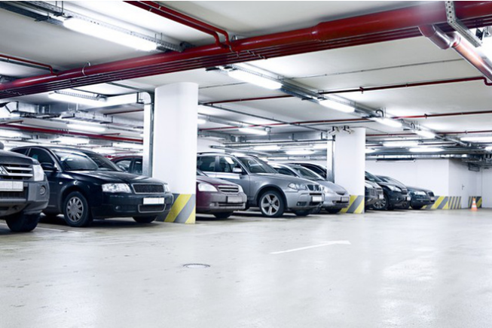

Figure : Indoor parking area

Indoor parking areas are growing with the increasing number of vehicles in a developing economy and causing many problems due to multiple floors, followed by zones, distributed parking lots and absence of parking guidance to vehicles drivers. The traditional method of having to navigate around searching for an empty parking lot causes many troubles for drivers, as well as traffic jam in parking areas.

### Outdoor parking area

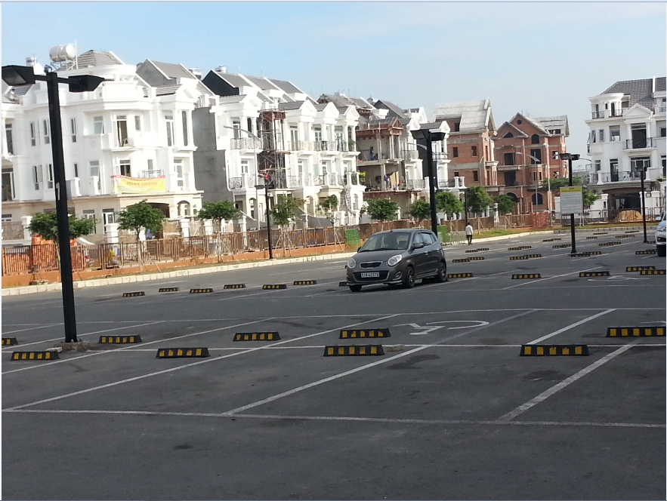

Figure : Outdoor parking area

With the increasing number of vehicles, it creates lots of issues to build a parking building, or a basement plus some other kind of building on top, especially cost and planning structure. There is no other way except to utilize outdoor spaces of places like public parks, mall, hospital… as an outdoor parking areas.

### Traditional PGS

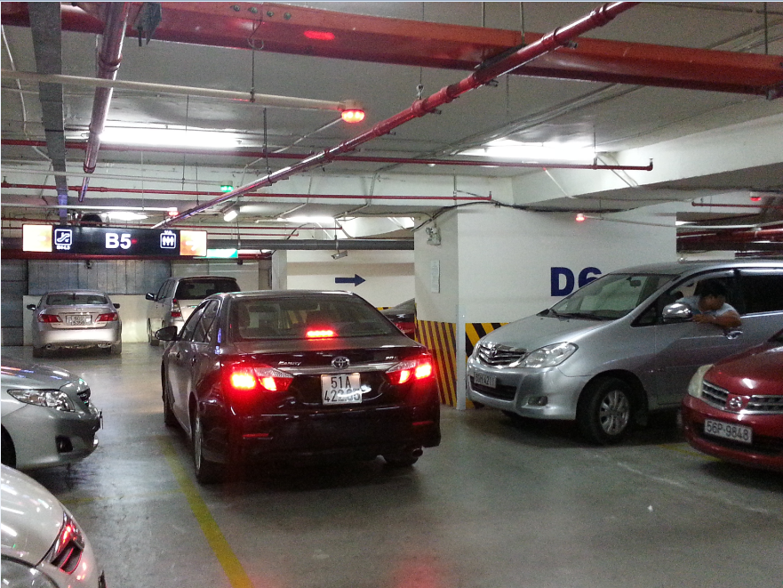

Figure : Parking area with PGS

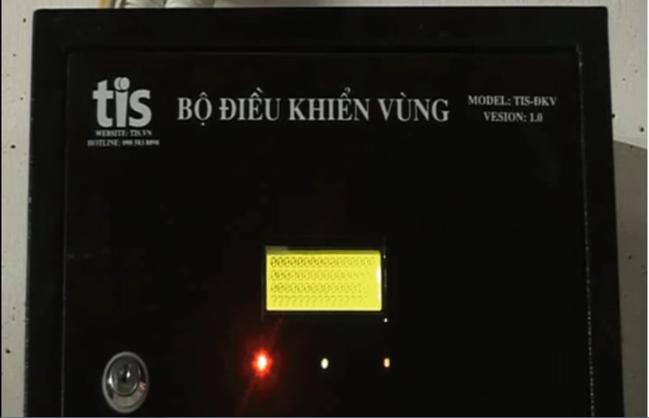

Figure : Zone Control Unit

As opposed to the traditional parking areas, the parking areas with PGS keep parking lots under systematic real-time monitoring so as drivers can see what parking spaces are available immediately and with minimal effort. By implementing this, operators also have the chance of increasing their revenues because of the increasing number of satisfied drivers.

The current version of PGS that implemented in a large number parking areas in Vietnam made use of RS485. Each parking lot is fitted with an ultrasonic detector and Indicator light, hence information displays at main entrance and at internal junction points are driven with real-time occupancy detected by ultrasonic detectors. All status sent to a Zone Control Unit on RS485, which in turn be sent to the Central Control Unit.

## Problem Definition

The current version of PGS is working well but it still has some disadvantages:

* The system implements the RS485 so each Zone Control Unit can have maximum 8 loops of 32 Detectors hence supporting 256 parking lots with 8 Information LED Displays. This is fine for most of the current parking areas, but it provides complicated in a parking area with large number of parking lots like the 6 multi-story car parks with around 7000 parking lots each proposed by Ho Chi Minh City Transport Department.
* The Zone Control Units need to be wired with Detectors, Indicator LED, Information LED Displays and Central Control Unit hence the wiring is pretty complicated and need careful planning in the construction stage. Therefore, the current version of PGS is hard to implement in most of the existed parking areas.
* The current version of PGS is difficult to use for outdoor parking areas because of the need of installation of the frame.
* Drivers can only get the information of available parking lots at the entrance of parking areas, so the issues of high proportion of traffic generated by drivers seeking vacant parking lots still remains.

## Proposed Solution

The current version of PGS contains many flaws and proved to be unacceptable for a greater business. Therefore, our proposed solution is to build a parking guidance system with RF modules. The RF modules provide wireless communication directly between Central Control Unit and Detectors, Indicator LED, Information LED Displays so there is no need for the Zone Control Units.

### Feature functions

#### Parking Guidance System

* Detectors sends out ultrasonic signals from the bottom upward and transmits the signals to the guidance units through RF.
* The Indicator LED, Information LED Displays also use RF communication so they are easier to install.
* The Central Control Unit connect with data stream network to provide real-time information to the app.

#### Mobile app

* Management portal for operators to setup and manage theirs parking area.
* Customer portal where drivers can view on maps the real time information of nearby parking areas or search for one.

### Advantages

* Fast orientation of drivers when seeking vacant parking lots
* Minimizing the time needed for finding a vacant parking lot
* Improvement of safety, the increase of the traffic effectiveness and efficiency
* Decreases of exhaust fumes as well as the negative impact of traffic on the environment
* Maximum use of the entire car park capacity
* Easy to assemble

### Disadvantages

* System does not provide car find feature
* The detector can only detect at the location above it so it can’t detect if there is anything around the corner of parking lot
* Management portal does not have web version

## Functional Requirements

Function requirements of the system are listed as below:

* Detector component:
  + Sensor (ultrasonic, infrared, magnetic field, load cell…)
  + RF communication
* Indicator LED component:
  + RGB led controller
  + RF communication
* Information LED Displays component:
  + Main entrance LED Display
  + Internal junction points LED Display
  + RF communication
* Reservation Barrier component:
  + Servo motor controller
  + RF communication
* Central Control System component:
  + Data Stream Network
  + Web API communication
  + RF communication
* Management portal app component:
  + Parking Area Setup
  + Parking Area Analysis
  + Parking Lot Control
* Customer portal app component:
  + Parking Areas Search
  + Parking Lot Reservation
* Web API component:
  + Parking Areas Search
  + Parking Area Setup
  + Parking Area Analysis
  + Parking Lot Status

## Roles and Responsibilities

| **No** | **Full name** | **Role** | **Position** | **Contact** |
| --- | --- | --- | --- | --- |
| 1 | Nguyễn Đức Lợi | Project manager | Supervisor | loind@fpt.edu.vn |
| 2 | Trần Nguyễn Minh Trung | Developer | Leader | trungtnmse61496@fpt.edu.vn |
| 3 | Bùi Phú Hiệp | Developer | Member | hiepbpse61438@fpt.edu.vn |
| 4 | Nguyễn Đỗ Phương Huy | Developer | Member | huyndpse61358@fpt.edu.vn |

Table : Roles and Responsibilities

## Conclusion

For this project, we will try to to reproduce the traditional Parking Guidance System with wireless technology, add a web server to manage information, a mobile app to provide UI for normal users and parking area operators to make this more like an IoT application. Therefore, we will need to:

* Research to determine and implement the appropriate MCU for the Central Control Unit and other nodes (**Arduino, Raspberry**, CC1310…)
* Research to determine and implement the appropriate sensor for the Detector (ultrasonic sensor, infrared sensor, **magnetic sensor**, load sensor…)
* Research to determine and implement the appropriate RF value and module to provide communication between nodes for the project (315Mhz, 433Mhz, **2.4Ghz**…)
* Research and implement LED RGB, seven-segment LED
* Research and implement real-time communication channel
* Research and host Web API on a cloud service
* Study and develop a mobile application (**Android**, iOS, Windows phone…)
* Study and develop program using embedded language (**Arduino**, C, **C++**, **Python**, Java Embedded, C#…)
* Study and create a Web API (Spring MVC, **ASP.NET**, Ruby…)
* Study and create a database (**SQL**, Oracle, MySQL, **SQLite** …)

# B. Software – Hardware Project Management Plan

## Problem Definition

### Name of this Capstone Project

* Official name: Parking Guidance System Solution
* Vietnamese name: Giải pháp hệ thống chỉ dẫn đỗ xe
* Abbreviation: PGSS

### Problem Abstract

As the economy of Vietnam growth, the number of personal cars also increasing, and that create a high proportion of traffic generated by drivers seeking vacant sparking lots. The current common Parking Guidance Systems in Vietnam are only suitable for a small number of indoor parking areas, and can’t be implemented for outdoor parking areas, because of the need of complicated planning and wiring. Moreover, all of the current PGS parking areas are working separately in their own local area network so there is no way for drivers to know the current available parking lots except by coming to the entrance.

We provide a system which ease the complicated in set up a PGS for parking areas. Furthermore, we make the system in a way that each PGS parking area can connect to each other so we can provide more information to drivers to help them find a suitable parking areas more quickly and easily.

### Project Overview

#### Current Situation

In the market, we have some ways to manage car park:

* The guard check each car in each parking lot:
  + Advantages:
    - Can check empty or using slot exactly
  + Disadvantages:
    - Consume people’s energy
    - Need much time to check all the parking lot
* Tradition PGS base on RS-485:
  + Advantages:
    - Can automatically check the empty slot in car park
  + Disadvantages:
    - Limited number of managed parking lots
    - Complicated wired system
    - Limited information provided to drivers

#### The Proposed System

Based on the result of our research, we propose the following solution: A Parking Guidance System based on Internet of Things that utilize the RF wireless technology to communicate between components. The system consists of Detectors, Indicator LED, Information LED Displays, Reservation Barrier, Central Control Unit, Web API Server and a Mobile Application.

After the Detector detect a car in the parking lot, it will send a signal to the Central Control Unit (CCU). The CCU will command the Indicator LED above that parking lot change to occupied color, update all related Information LED Displays, send a message to Web API Server to update information of parking lot on the server and Mobile Application.

In case of users want to reserve a parking lot in the parking area, they can use the Mobile Application to make a reservation. The Web API Server will update the database based on the reservation and the Reservation Barrier will lock the reserved parking lot.

##### Interaction Block

* This block will be place in each parking lot to check existed car and control signal light, barrier.
* Arduino is the main board to control the Interaction block, which show information to the end customer.
* Ultrasonic sensor is used to check the existed car in each parking lot
* DC Servo to monitor the barrier.
* 12A DC-to-DC step down module used to convert voltage high-to-low for other hardware.

##### Information Block

* This is the led panel in each area to show the number of empty slot in each area.
* Arduino is also the main board to control this block.

##### Central Control Unit

* This will be the central point of all Interaction Module.
* It will be control be Raspberry Pi 3.
* Send and receive data from server to analyze then monitor the Interaction Block.

##### Web API Server

* ASP.NET API to communicate between the mobile app, database and CCU.
* Get the position of each car park base on address to view on mobile app.

##### Mobile Application

* Our priority OS for Mobile Application is Android because of a higher market share than other mobile OS and a lower barrier of entry
* The App utilizes the Google Map API to provide an interactive map that show in real time the available parking lots in each parking areas.

#### Boundaries of the System

* System is available for both manager and end user.
* The language of system is English
* The input and output of system is car slot
* The boundaries of mechanical parts include:
  + End user need to park their car correctly in parking lot.
  + The information, which show number of empty slot may delay 5-10 seconds when the system start.
  + The system will run correctly when the weather condition is good.
* The boundaries of mobile application include:
  + End user only pay for the booking time, not pay the parking time on mobile app.
  + Need connect to internet to run smoothly.
* The complete product includes:
  + The entire PGSS system in car park.
  + The mobile application for manager and end user.
  + The database to store all needed information.
  + All the documents of the project.



Figure : Project Block Diagram

#### Future Plans

There are no perfect solutions to problems, as well as there are no perfect systems. With the inexperience of our team members and the time constrains, our proposed solution and project contains many issues. Below are the problems encountered in this project:

* **Parking Operate Knowledge:** We are not experts in parking operating. All functions and features are developed in order to serve the needs which we had identified during 4 months of research.
* **Hardware Knowledge:** We are inexperienced with hardware. All the hardware components chosen to be used in this project is based on our familiar with them, or based on the shortest time we need to learn how to use them. So they are only the most appropriate, not the best choice for the project.
* **Single point of failure:** The communication of the PGS system and server is highly depended on the Central Control Unit in each parking area. So if the Central Control Unit crash, the PGS can no longer commute with server.
* **Server crash:** All the needed data for the app is stored in the server. So if server crash, all the devices cannot get parking area information.
* **Security:** Currently, there is few possible problems encountered with RF, as RF is vulnerable to replay attack.

Our future plan is try to solve these problems one by one. We design the system with separated modules in mind to make it easy to change one module without affect others and we also make it easy to scale to bigger models.

#### Development Environment

##### Hardware requirements

**For Web API Server**

|  |  |
| --- | --- |
| **Components** | **Requirement** |
| DTU | 10 DTU |
| Storage | 250 GB |

Table : Database requirement

|  |  |
| --- | --- |
| **Components** | **Requirement** |
| Number of cores | 1 core |
| RAM | 1.75 GB Ram |
| Storage | 10 GB |

Table : API Service Requirement

**For CCU**

|  |  |
| --- | --- |
| **Components** | **Hardware** |
| Mainboard | Raspberry Pi 3 |
| Communication | USB Cable |
| Sensor Devices | Magnetometer |
| Motors | Servo |
| Power Source |  |

Table : Provide CCU Hardware

##### Software requirements

* Windows XP/7/8/10: operating system for developing and deploying.
* SQL Server Express 2012: used to create and manage database for PGSS.
* Visual Studio 2015: used to develop API.
* Arduino IDE: used to develop Arduino program.
* Proteus 8: used to drawing board with other hardware.
* Github & SourceTree: used for source control.
* StarUML: used to create models and diagrams.
* Slack: used for communication and meeting.
* C/C++: used for embedded module
* Python 3: used for Central Control Unit
* C#: used for web server
* Java: used for mobile application

## Project organization

### Software Process Model

This project is developed under Iterative and incremental development model. We apply customized Iterative and incremental development model to capable with current situation in our team. We choose this model because of the following reasons:

* We are still inexperienced and by develop the system through iterations (repeated cycles) and incrementally (in small portions of time), we can learn from our mistakes and apply that knowledge on the next iteration.
* We are researching and developing the system at the same time, so using this model allow us more flexibility to adapt to changes.
* Working with embedded system hides a lot of problems that are unknown in the planning phase until it is too late. With Iterative and incremental development model, we test the system in small portion at a time, therefore reduce risk and build a feature rich and robust system.

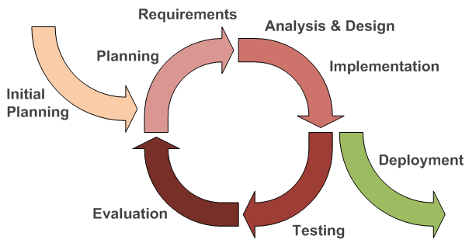

Figure : Iterative and Incremental development

### Roles and responsibilities

|  |  |  |  |
| --- | --- | --- | --- |
| **No** | **Full name** | **Team Role** | **Responsibilities** |
| 1 | Nguyễn Đức Lợi | Supervisor, Project Manager | * Specify user requirement * Advisor for ideas and solutions * Control the development process * Give out techniques and business analysis support |
| 2 | Trần Nguyễn Minh Trung | Team Leader, BA, Developer, Tester | * Managing process * Managing budget * Dividing tasks for team member * Create test plan * Clarifying requirements * Prepare document * Coding * Testing |
| 3 | Bùi Phú Hiệp | Team Member, Developer, Tester | * Create test plan * Clarifying requirements * Prepare document * Coding * Testing |
| 4 | Nguyễn Đỗ Phương Huy | Team Member, Developer, Tester | * Create test plan * Clarifying requirements * Prepare document * Coding * Testing |

Table : Roles and Responsibilities Details

### Tools and Techniques

|  |  |
| --- | --- |
| **Tools** | |
| Operating System | Windows 7 Ultimate |
| Raspbian Jessie |
| Developing tool | Android Studio |
| Visual Studio 2015 Community |
| IDLE 3 |
| Arduino IDE 1.6.12 |
| Managing Database | SQL Server 2014 Management Studio |
| Source Control | Git 2.8.1 (Server https://github.com) |
| SourceTree 1.9.10 |
| Communication tool | Gmail |
| Slack |
| Trello |
| Models and Diagrams tool | <https://www.draw.io/>, StarUML |

Table : Tools

|  |  |
| --- | --- |
| **Techniques** | |
| Embedded System | C/C++ |
| Arduino |
| Python 3 |
| Mobile System | Android SDK |
| Retrofit 2 |
| Google Map |
| Web Server System | Azure Cloud |
|  | ASP.NET |
| Database Management System | SQL Server 2014 |
|  | SQLite 3.7 |

Table : Techniques

## Project Management Plan

*References to main document, Section B – 3. Project Management Plan*

## Coding Convention

*References to main document, Section B – 4. Coding Convention*

# C. Software – Hardware Requirement Specification

## Software Requirement Specification

### Software Requirement

Manager can show the information of their car park to the end user, which will increase the interaction between car park provider and end user. The information includes:

* Address
* Contact info
* Number of empty parking lot

End user can find the nearest car park, which has empty parking lot.

Manager can manage their car park easily; make an automatic system to guide the end user base on the interaction panel, which show number of empty parking lot in each area and the status light on each parking lot.

Users can see empty slot and detail information about parking area by touching a marker on map.

User can reserve a parking slot.

### GUI Requirement

User interface of mobile app must be simple, clearly and easy to use.

The color of mobile app must be elegant, not garish.

Each UI element must be arranged logically, allowing user access easily.

Meet all main function requirements.

## Hardware Requirement Specification

### Hardware Requirement

#### Hardware Interface

The hardware interface must have satisfied the following requirements:

* Easy to replace
* Low-cost module
* Easy to implement

Based on project requirement we have choose following hardware components.

##### Block Diagram

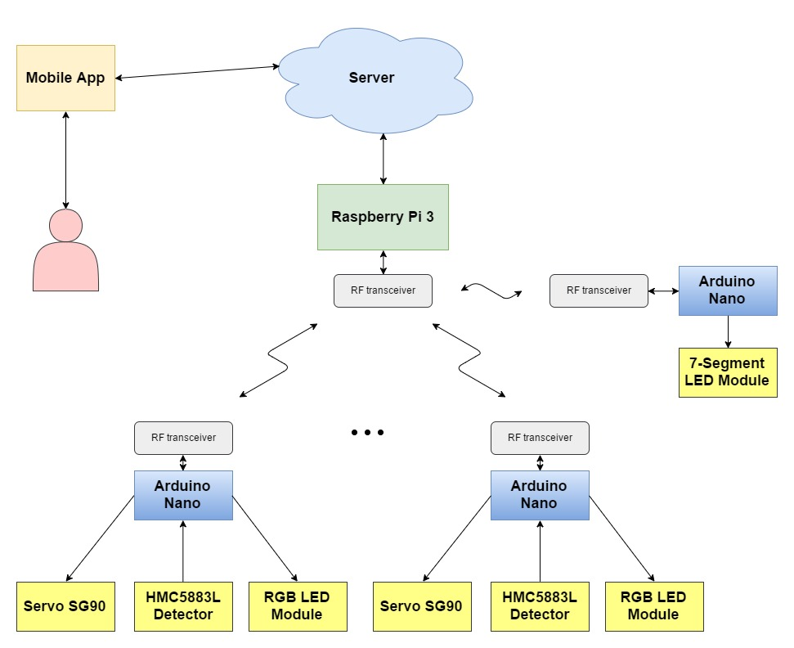

Figure : PGSS Block Diagram

This block diagram shows the basic concept IoT provided in the project. The Raspberry Pi 3 will play as Hub role, and Arduino Nano will play as Node role, which communicate with Hub through RF transceiver. The Hub also connect to a Cloud Server, provides the ability for User to interactive with through a Mobile App that also connect to the same Cloud Server.

##### Raspberry Pi 3

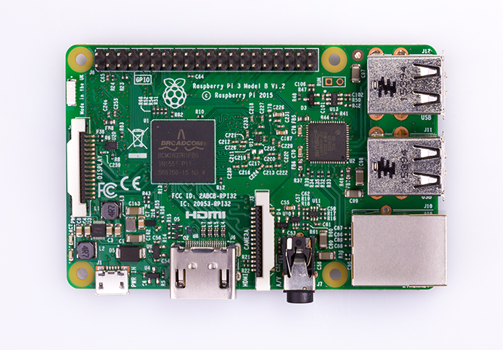

Figure : Raspberry Pi 3

**Overview:** To communicate with all other hardware component and processing value, we must have a Central control unit, there are many kind of central control unit in the market. After evaluate requirement of project, we decide to choose Raspberry Pi 3. Raspberry Pi 3 is powerful mini-computer with many features.

**Specification:**

|  |  |
| --- | --- |
| SoC | Broadcom BCM2837 |
| CPU | 4× ARM Cortex-A53, 1.2GHz |
| GPU | Broadcom VideoCore IV |
| RAM | 1GB LPDDR2 (900 MHz) |
| Network | 10/100 Ethernet, 2.4GHz 802.11n wireless |
| Bluetooth | Bluetooth 4.1 Classic, Bluetooth Low Energy |
| Storage | microSD |
| GPIO | 40 |

Table : Raspberry Pi 3 – Specification

More details about Raspberry Pi 3:

<https://www.raspberrypi.org/products/raspberry-pi-3-model-b/>

##### Arduino Nano

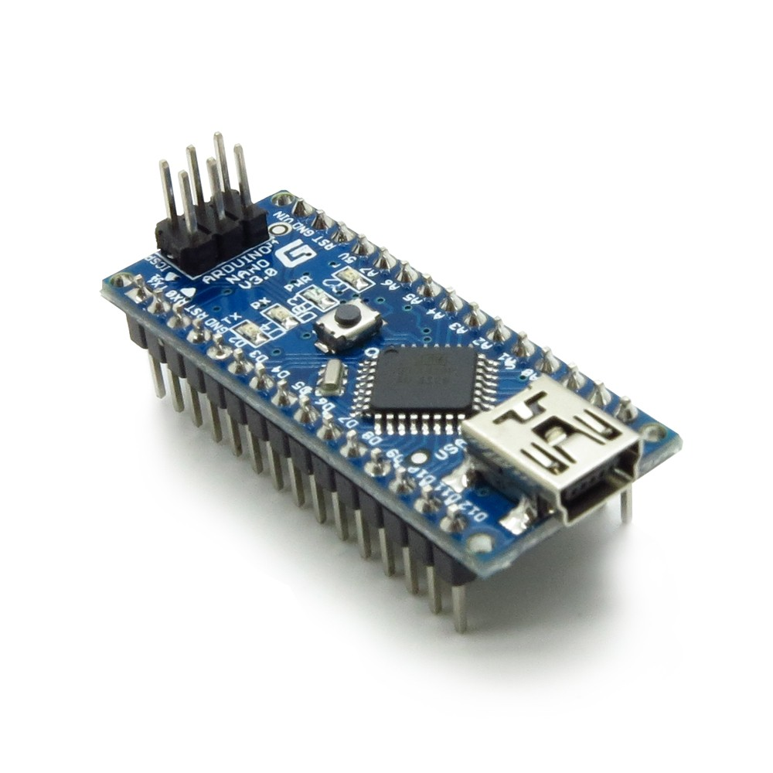

Figure : Arduino Nano

**Overview:** The Arduino Nano is a small, complete, and breadboard-friendly board based on the ATmega328 (Arduino Nano 3.x).

**Specification:**

|  |  |
| --- | --- |
| Microcontroller | ATmega328 |
| Architecture | AVR |
| Operating Voltage | 5 V |
| Flash Memory | 32 KB of which 2 KB used by bootloader |
| SRAM | 2 KB |
| Clock Speed | 16 MHz |
| Analog I/O Pins | 8 |
| EEPROM | 1 KB |
| DC Current per I/O Pins | 40 mA (I/O Pins) |
| Input Voltage | 7-12 V |
| Digital I/O Pins | 22 |
| PWM Output | 6 |
| Power Consumption | 19 mA |
| PCB Size | 18 x 45 mm |
| Weight | 7 g |
| Product Code | A000005 |

Table : Arduino Nano - Specification

More detail about Arduino Nano:

<https://www.arduino.cc/en/Main/arduinoBoardNano>

##### Compass Module 3-Axis HMC5883L

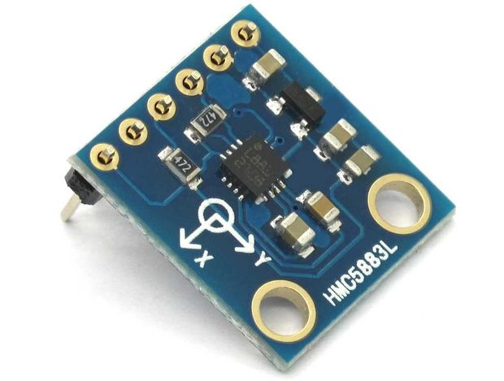

Figure : Compass Module 3-Axis HMC5883L

**Overview:** For detecting obstacle, we choose The Compass Module 3-Axis HMC5883L instead of ultrasonic sensor because ultrasonic sensor has many weaknesses, they are not accuracy, cannot be used outdoor in the bad weather in Vietnam.

The Compass Module 3-Axis HMC5883L is a low-field magnetic sensing device with a digital interface.

We choose The Compass Module 3-Axis HMC5883L because:

* It has reasonable price.
* Compatible with arduino and other board.
* Compact size.

**Specification:**

Input and Output Pins:

|  |  |  |  |
| --- | --- | --- | --- |
| **Pin** | | **I/O** | **Function** |
| **Name** | **No.** |
| **VIN** | **1** |  | Supply Voltage – 2.7 to 6.5 VDC |
| **GND** | **2** |  | Ground |
| **SCL** | **3** | **I** | I²C Clock |
| **SDA** | **4** | **IO** | I²C Data |
| **RDY** | **5** | **I** | Data Ready |

Table : The Compass Module 3-Axis HMC5883L - Pin Function

##### RF module nRF24L01+

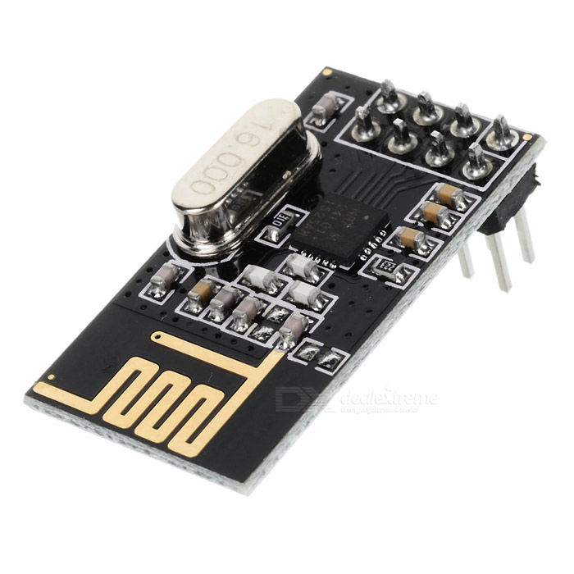

Figure : RF module nRF24L01+

**Overview:** Reason for PGSS use RF module nRF24L01 to communicate between Central control unit and other hardware component:

* It has reasonable price.
* Easy to buy.
* Ultra low power consumption.

**Specification:**

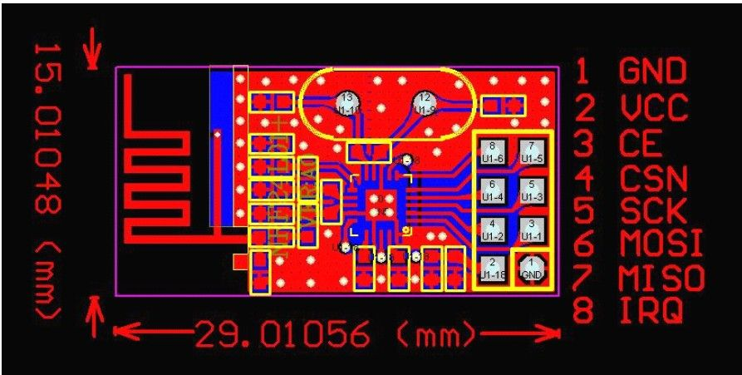

Figure : RF module nRF24L01+ - Specification

|  |  |  |  |
| --- | --- | --- | --- |
| **Pin** | | **I/O** | **Description** |
| **No.** | **Name** |
| 1 | GND |  | Power Supply Ground |
| 2 | VCC |  | 3.3V |
| 3 | CE | I | Chip Enable |
| 4 | CSN | I | SPI Chip Select |
| 5 | SCK | I | SPI Clock |
| 6 | MOSI | I | SPI Slave Data Input |
| 7 | MISO | O | SPI Slave Data Output |
| 8 | IRQ | O | Maskable Interrupt Pin |

Table : RF Module nRF24L01 – Pin function

##### Information LED Display Module

Information LED Display Module include: 7-segment LED Display, TPIC6B595 Power Logic 8-Bit Shift Register

###### **F:\CP\Image\7seg.jpg7-segment LED Display**

Figure : 7-segment LED Display

**Specification:**

* 0.56 inch digit height
* Super Red emitting color
* White segment color, gray face
* Low current operation
* Easy mounting on PCB boards or sockets

###### **TPIC6B595 Power Logic 8-Bit Shift Register**

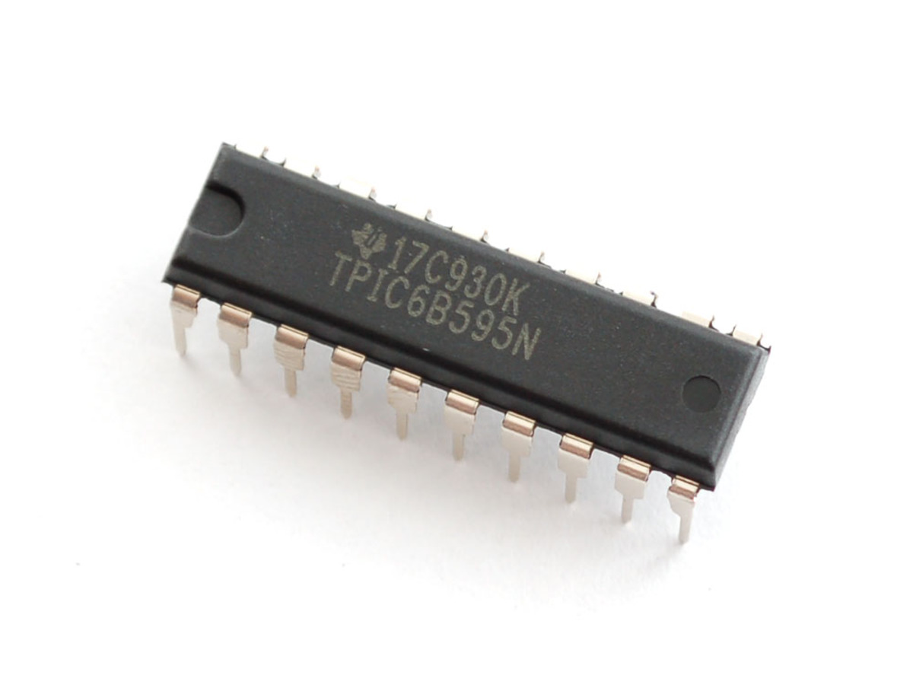

Figure : TPIC6B595 Power Logic 8-Bit Shift Register

**Specification:**

To display high power 7-segment display, we choose IC TPIC6B595 instead of IC 74HC595 because TPIC6B595 is asimple shift register IC that can control high-voltage/high-current devices directly**.** Each output pin can sink 150mA and then supports the maximum of Load Voltage at 50V.

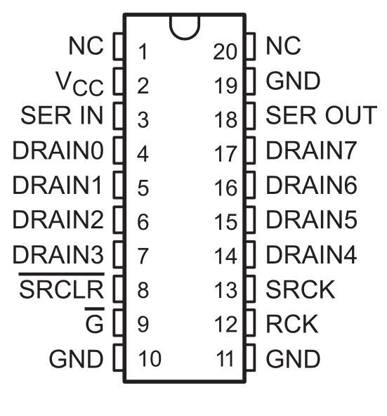

Figure : TPIC6B595 Pin-outs

|  |  |  |  |
| --- | --- | --- | --- |
| **Pin** | | **I/O** | **Description** |
| **Name** | **No.** | O | Open-drain output |
| DRAIN0 | 4 |
| DRAIN1 | 5 |
| DRAIN2 | 6 |
| DRAIN3 | 7 |
| DRAIN4 | 14 |
| DRAIN5 | 15 |
| DRAIN6 | 16 |
| DRAIN7 | 17 |
| G | 9 | I | Output enable, active-low |
| GND | 10,11,19 | - | Power ground |
| NC | 1, 20 | - | No internal connection |
| RCK | 12 | I | Register clock |
| SERIN | 3 | I | Serial data input |
| SEROUT | 18 | O | Serial data output |
| SRCK | 15 | I | Shift register clock |
| SRCLR | 8 | I | Shift register clear, active-low |
| VCC | 2 | I | Power supply |

Table : IC TPIC6B595 - Pin Function

##### Indicator LED Module

Indicator LED Module include: Common anode RGB LED, TIP122 Transistor

###### **RGB LED common anode**

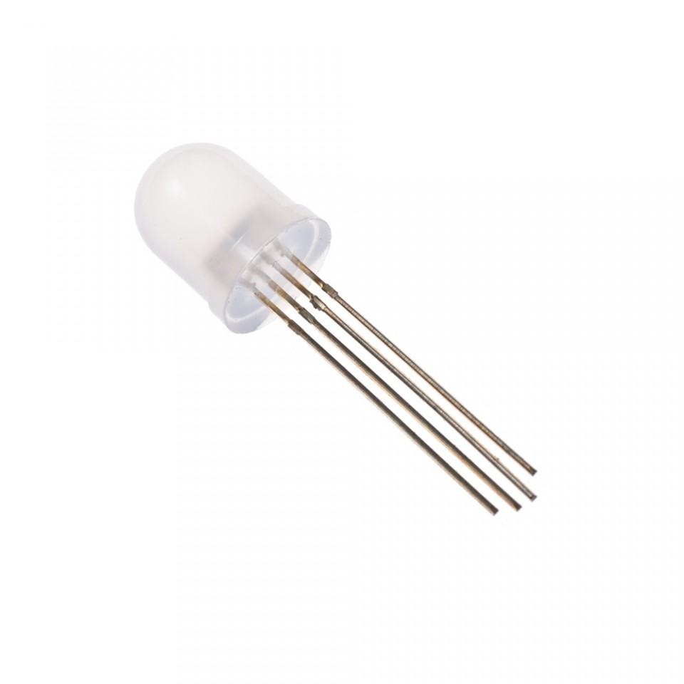

Figure : RGB LED common anode

**Overview:**

RGB LED allows you to change the lights to any color to show state of parking slot.

**Specification:**

* Forward Voltage (RGB): (2.0, 3.2, 3.2)V
* Max Forward Current (RGB): (20, 20, 20)mA
* Max Luminosity (RGB): (2800, 6500, 1200)mcd

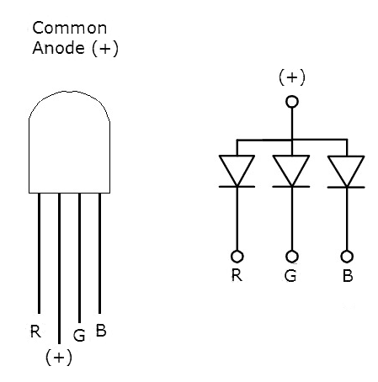

Figure : RGB LED common anode pin-out

###### **TIP122 Transistor**



Figure 12:: TIP122 Transistor

**Overview:** A single digital pin on Arduino Nano do not provide enough current to power RGB LED, A solution for this situation is to use an NPN Darlington Transistor designed for medium power linear switching applications, so we use TIP122 Transistor to provide RGB LED with power from an external source. It can power devices up to 100VDC at 5 Amps.

**Specification:**

* TIP122 is power transistors
* Collector Current: 5 ampere
* Collector-Emitter Volt: 100 volts
* Power Dissipation: 65 watts

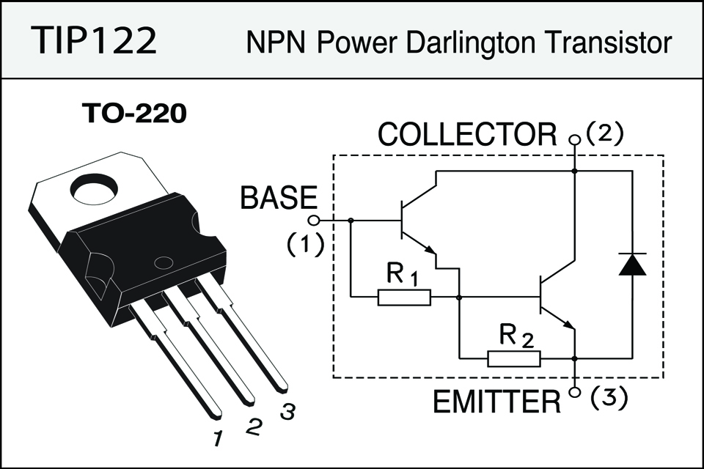

Figure 12: TIP122 Transistor- Pin Layout

##### Servo Motor SG90

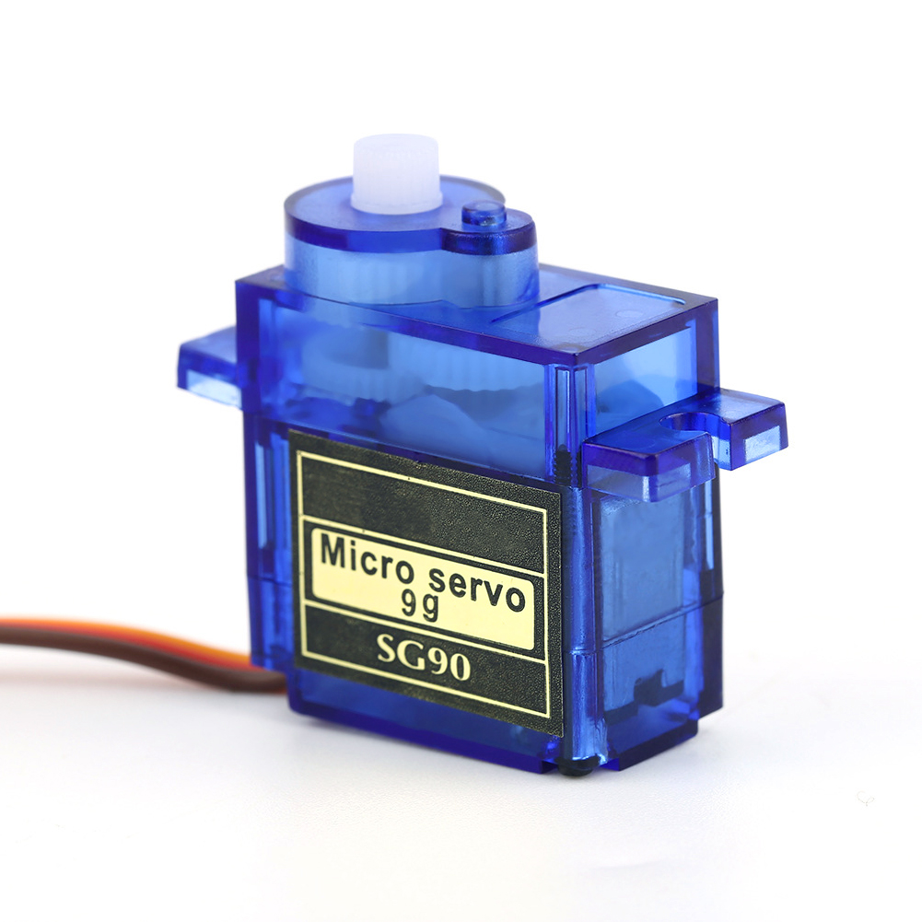

Figure 13:: Servo Motor – Tower Pro SG90

**Overview:** PGSS use Servo Motor SG90 to control barrier at each parking slot.

**Specification:**

|  |  |
| --- | --- |
| **Torque** | 1.80 kg-cm at 4.8V |
| **Speed** | 0.1sec/60° at 4.8V |
| **Voltage** | 4.0V to 7.2V, 4.6V - 5.2V nominal |
| **Dimensions** | 23mm x 12.2mm x 29mm |
| **Rotation range** | 180o |
| **Weight** | 9g |
| **Pulse width** | 500-2400uS |
| **Operating Temperature range** | 30°C to 60°C |

Table 7: Servo Motor SG90 – Specification

|  |  |  |
| --- | --- | --- |
| **Pin of Servo SG90** | **Name** | **Description** |
| Red | VCC | Power supply 5V |
| Black | GND | Power supply ground |
| Yellow | Signal | The servo will move based on the signal sent to signal wire. |

Table : Servo Motor SG90 – Pin-outs

#### Communication Protocol

* We communicate between hardware component and board through GPIO pin.
* Arduino Nano board communicate with Raspberry Pi 3 via RF Module.

### System Overview Use Case

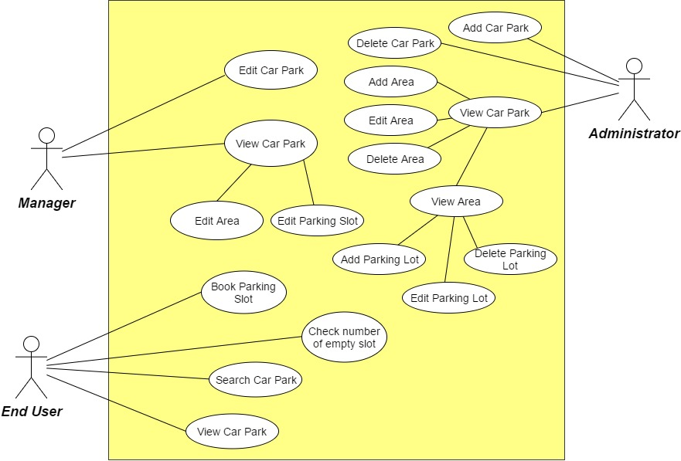

Figure : Overview Use Case Diagram

### List of Use Case

#### Manager Use Case

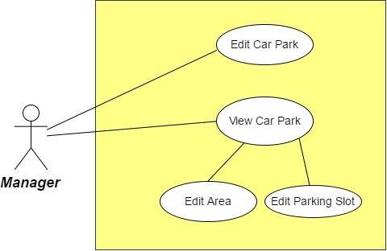

Figure : Manager Use Case Diagram

**Use case specifications**

|  |  |  |  |
| --- | --- | --- | --- |
| **Use Case-1 specification** | | | |
| **Use-case no.** | PGSS01 | **Use-case version** | 1.0 |
| **Use-case name** | Edit Car Park | | |
| **Author** | Bui Phu Hiep | | |
| **Date** | 13/02/17 | **Priority** | High |
| **Actor:**   * Manager   **Summary:**   * This use case allow user to change the configuration of their system.   **Goal:**   * Manager can change the information of car park, which show to the end user.   **Triggers:**   * User click on once car park button.   **Preconditions:**   * Mobile application is already launch. * Manager has been logged in   **Post Conditions:**   * **On Success:** New configuration is apply and save to server * **On Failure:** Show error message   **Main Success Scenario:**   |  |  |  | | --- | --- | --- | | **No.** | **Actor Action** | **System Response** | | 1 | User select once car park | Show the car park detail information on mobile | | 2 | User click on “Setting” button | Application navigate to “Setting” menu | | 3 | User select option in the Menu  Change by click toggle or change value in the text box  Select “Submit” button | Change the value and save to server |   **Alternative Scenario:**   * N/A   **Exceptions:**   * N/A   **Business Rules:**   * N/A | | | |

|  |  |  |  |
| --- | --- | --- | --- |
| **Use Case-2 specification** | | | |
| **Use-case no.** | PGSS02 | **Use-case version** | 1.0 |
| **Use-case name** | View Car Park | | |
| **Author** | Bui Phu Hiep | | |
| **Date** | 13/02/17 | **Priority** | High |
| **Actor:**   * Manager   **Summary:**   * This use case allow user to view their car park info.   **Goal:**   * User can view the information of car park.   **Triggers:**   * User select their car park.   **Preconditions:**   * Mobile application is already launch. * Manager has been logged in   **Post Conditions:**   * **On Success:** User can view the information of car park. * **On Failure:** Show error message   **Main Success Scenario:**   |  |  |  | | --- | --- | --- | | **No.** | **Actor Action** | **System Response** | | 1 | User select once car park | Show the car park detail information on mobile |   **Alternative Scenario:**   * N/A   **Exceptions:**   * N/A   **Business Rules:**   * N/A | | | |

|  |  |  |  |
| --- | --- | --- | --- |
| **Use Case-3 specification** | | | |
| **Use-case no.** | PGSS03 | **Use-case version** | 1.0 |
| **Use-case name** | Edit Area | | |
| **Author** | Bui Phu Hiep | | |
| **Date** | 13/02/17 | **Priority** | High |
| **Actor:**   * Manager   **Summary:**   * This use case allow user to change the status of each area.   **Goal:**   * The status of selected area updated and change in mobile app.   **Triggers:**   * User select their car park. * User select area in selected car park.   **Preconditions:**   * Mobile application is already launch. * Manager has been logged in   **Post Conditions:**   * **On Success:** New configuration is apply and save to server * **On Failure:** Show error message   **Main Success Scenario:**   |  |  |  | | --- | --- | --- | | **No.** | **Actor Action** | **System Response** | | 1 | User select car park | Application change to car park detail page | | 2 | User select area in the selected car park | Application change to area detail page | | 3 | User select status in the drop down list.  Click “Update” button | The status of the area will change on server and update in mobile application |   **Alternative Scenario:**   * N/A   **Exceptions:**   * N/A   **Business Rules:**   * N/A | | | |

|  |  |  |  |
| --- | --- | --- | --- |
| **Use Case-4 specification** | | | |
| **Use-case no.** | PGSS04 | **Use-case version** | 1.0 |
| **Use-case name** | Edit Parking Slot | | |
| **Author** | Bui Phu Hiep | | |
| **Date** | 13/02/17 | **Priority** | High |
| **Actor:**   * Manager   **Summary:**   * This use case allow user to manage the parking slot.   **Goal:**   * The status of selected area updated and change in mobile app.   **Triggers:**   * User select their car park. * User select area in selected car park. * Then select parking slot   **Preconditions:**   * Mobile application is already launch. * Manager has been logged in   **Post Conditions:**   * **On Success:** New configuration is apply and save to server * **On Failure:** Show error message   **Main Success Scenario:**   |  |  |  | | --- | --- | --- | | **No.** | **Actor Action** | **System Response** | | 1 | User select car park | Application change to car park detail page | | 2 | User select area in the selected car park | Application change to area detail page | | 3 | User select parking slot to edit  After change information, select “Update” button | The information of parking slot is change on server and update in mobile application. |   **Alternative Scenario:**   |  |  |  | | --- | --- | --- | | **No.** | **Actor Action** | **System Response** | | 1 | User select car park | Application change to car park detail page | | 2 | User select area in the selected car park | Application change to area detail page | | 3 | User click menu beside list parking spot to delete. | The parking spot will be set to deleted in server and update in mobile app. |   **Exceptions:**   * N/A   **Business Rules:**   * N/A | | | |

#### Administrator Use Case

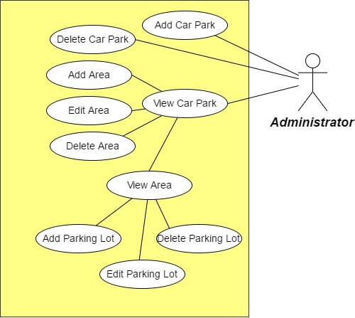

Figure : Manager Use Case Diagram

|  |  |  |  |
| --- | --- | --- | --- |
| **Use Case-5 specification** | | | |
| **Use-case no.** | PGSS05 | **Use-case version** | 1.0 |
| **Use-case name** | Add Car Park | | |
| **Author** | Bui Phu Hiep | | |
| **Date** | 13/02/17 | **Priority** | High |
| **Actor:**   * Administrator   **Summary:**   * This use case allow user to add new car park to the system   **Goal:**   * New car park is added and save to server.   **Triggers:**   * User click on “Add” button.   **Preconditions:**   * Mobile application is already launch. * Administrator has been logged in   **Post Conditions:**   * **On Success:** New car park is save to server * **On Failure:** Show error message   **Main Success Scenario:**   |  |  |  | | --- | --- | --- | | **No.** | **Actor Action** | **System Response** | | 1 | User click on “Add” or “+” button | Application navigate to add car park menu | | 2 | User fill in the textbox  Select “Submit” button | New car park with filled in info is added to server |   **Alternative Scenario:**   * N/A   **Exceptions:**   * Name of the car park is unique * Address of the car park is unique (don’t has same latitude and longitude)   **Business Rules:**   * N/A | | | |

|  |  |  |  |
| --- | --- | --- | --- |
| **Use Case-6 specification** | | | |
| **Use-case no.** | PGSS06 | **Use-case version** | 1.0 |
| **Use-case name** | Delete Car Park | | |
| **Author** | Bui Phu Hiep | | |
| **Date** | 13/02/17 | **Priority** | High |
| **Actor:**   * Administrator   **Summary:**   * This use case allow user to delete a car park on the system   **Goal:**   * Delete a car park on the server   **Triggers:**   * User click on “x” button.   **Preconditions:**   * Mobile application is already launch. * Administrator has been logged in   **Post Conditions:**   * **On Success:** Delete a car park on server * **On Failure:** Show error message   **Main Success Scenario:**   |  |  |  | | --- | --- | --- | | **No.** | **Actor Action** | **System Response** | | 1 | User click on “Remove” or “x” button | Application show the confirm button | | 2 | User click “Accept” | Car park is removed from the server |   **Alternative Scenario:**   * N/A   **Exceptions:**   * **N/A**   **Business Rules:**   * N/A | | | |

|  |  |  |  |
| --- | --- | --- | --- |
| **Use Case-7 specification** | | | |
| **Use-case no.** | PGSS07 | **Use-case version** | 1.0 |
| **Use-case name** | View Car Park | | |
| **Author** | Bui Phu Hiep | | |
| **Date** | 13/02/17 | **Priority** | High |
| **Actor:**   * Manager   **Summary:**   * This use case allow user to view car park info.   **Goal:**   * User can view the information of car park.   **Triggers:**   * User select the car park.   **Preconditions:**   * Mobile application is already launch. * Manager has been logged in   **Post Conditions:**   * **On Success:** User can view the information of car park. * **On Failure:** Show error message   **Main Success Scenario:**   |  |  |  | | --- | --- | --- | | **No.** | **Actor Action** | **System Response** | | 1 | User select once car park | Show the car park detail information on mobile |   **Alternative Scenario:**   * N/A   **Exceptions:**   * N/A   **Business Rules:**   * N/A | | | |

|  |  |  |  |
| --- | --- | --- | --- |
| **Use Case-8 specification** | | | |
| **Use-case no.** | PGSS08 | **Use-case version** | 1.0 |
| **Use-case name** | Add Area | | |
| **Author** | Bui Phu Hiep | | |
| **Date** | 13/02/17 | **Priority** | High |
| **Actor:**   * Administrator   **Summary:**   * This use case allow user to add new area to the system   **Goal:**   * New area is added and save to server.   **Triggers:**   * User select car park * User click on “Add” button.   **Preconditions:**   * Mobile application is already launch. * Administrator has been logged in   **Post Conditions:**   * **On Success:** New area is save to server * **On Failure:** Show error message   **Main Success Scenario:**   |  |  |  | | --- | --- | --- | | **No.** | **Actor Action** | **System Response** | | 1 | User select a car park | Show the car park detail information screen | | 2 | User click on “Add” or “+” button | Application navigate to add area menu | | 3 | User fill in the textbox  Select “Submit” button | New area with filled in info is added to server |   **Alternative Scenario:**   * N/A   **Exceptions:**   * N/A   **Business Rules:**   * N/A | | | |

|  |  |  |  |
| --- | --- | --- | --- |
| **Use Case-9 specification** | | | |
| **Use-case no.** | PGSS09 | **Use-case version** | 1.0 |
| **Use-case name** | Edit Area | | |
| **Author** | Bui Phu Hiep | | |
| **Date** | 13/02/17 | **Priority** | High |
| **Actor:**   * Administrator   **Summary:**   * This use case allow user to update to the system   **Goal:**   * New value is updated to server.   **Triggers:**   * User select car park * User click on “Edit” button next to an area.   **Preconditions:**   * Mobile application is already launch. * Administrator has been logged in   **Post Conditions:**   * **On Success:** New value is saved to server * **On Failure:** Show error message   **Main Success Scenario:**   |  |  |  | | --- | --- | --- | | **No.** | **Actor Action** | **System Response** | | 1 | User select a car park | Show the car park detail information screen | | 2 | User click on “Edit” button | Application navigate to edit area menu | | 3 | User fill in the textbox  Select “Submit” button | New value of area with filled in info is updated to server |   **Alternative Scenario:**   * N/A   **Exceptions:**   * N/A   **Business Rules:**   * N/A | | | |

|  |  |  |  |
| --- | --- | --- | --- |
| **Use Case-10 specification** | | | |
| **Use-case no.** | PGSS10 | **Use-case version** | 1.0 |
| **Use-case name** | Delete Area | | |
| **Author** | Bui Phu Hiep | | |
| **Date** | 13/02/17 | **Priority** | High |
| **Actor:**   * Administrator   **Summary:**   * This use case allow user to delete an area on the system   **Goal:**   * Delete an area on the server   **Triggers:**   * User select a car park * User click on “x” button next to the area.   **Preconditions:**   * Mobile application is already launch. * Administrator has been logged in   **Post Conditions:**   * **On Success:** Delete an area on server * **On Failure:** Show error message   **Main Success Scenario:**   |  |  |  | | --- | --- | --- | | **No.** | **Actor Action** | **System Response** | | 1 | User select once car park | Show the car park detail information on mobile | | 2 | User click on “Remove” or “x” button next to the area | Application show the confirm button | | 3 | User click “Accept” | Area is removed from the server |   **Alternative Scenario:**   * N/A   **Exceptions:**   * **N/A**   **Business Rules:**   * N/A | | | |

|  |  |  |  |
| --- | --- | --- | --- |
| **Use Case-11 specification** | | | |
| **Use-case no.** | PGSS11 | **Use-case version** | 1.0 |
| **Use-case name** | View Area | | |
| **Author** | Bui Phu Hiep | | |
| **Date** | 13/02/17 | **Priority** | High |
| **Actor:**   * Manager   **Summary:**   * This use case allow user to view area info.   **Goal:**   * User can view the information of area.   **Triggers:**   * User select the car park. * User select the area in car park   **Preconditions:**   * Mobile application is already launch. * Manager has been logged in   **Post Conditions:**   * **On Success:** User can view the information of area. * **On Failure:** Show error message   **Main Success Scenario:**   |  |  |  | | --- | --- | --- | | **No.** | **Actor Action** | **System Response** | | 1 | User select once car park | Show the car park detail information on mobile | | 2 | User select area in the list of area | Show the area information on mobile |   **Alternative Scenario:**   * N/A   **Exceptions:**   * N/A   **Business Rules:**   * N/A | | | |

|  |  |  |  |
| --- | --- | --- | --- |
| **Use Case-12 specification** | | | |
| **Use-case no.** | PGSS12 | **Use-case version** | 1.0 |
| **Use-case name** | Add Parking Lot | | |
| **Author** | Bui Phu Hiep | | |
| **Date** | 13/02/17 | **Priority** | High |
| **Actor:**   * Administrator   **Summary:**   * This use case allow user to add new parking lot to the system   **Goal:**   * New parking lot is added and save to server.   **Triggers:**   * User select area * User click on “Add” button.   **Preconditions:**   * Mobile application is already launch. * Administrator has been logged in   **Post Conditions:**   * **On Success:** New parking lot is saved to server * **On Failure:** Show error message   **Main Success Scenario:**   |  |  |  | | --- | --- | --- | | **No.** | **Actor Action** | **System Response** | | 1 | User select a car park | Show the car park detail information screen | | 2 | User select a area | Show the area information screen | | 3 | User click on “Add” or “+” button | Application navigate to add parking lot screen | | 3 | User fill in the textbox  Select “Submit” button | New parking lot with filled in info is added to server |   **Alternative Scenario:**   * N/A   **Exceptions:**   * N/A   **Business Rules:**   * N/A | | | |

|  |  |  |  |
| --- | --- | --- | --- |
| **Use Case-13 specification** | | | |
| **Use-case no.** | PGSS13 | **Use-case version** | 1.0 |
| **Use-case name** | Edit Parking Lot | | |
| **Author** | Bui Phu Hiep | | |
| **Date** | 13/02/17 | **Priority** | High |
| **Actor:**   * Administrator   **Summary:**   * This use case allow user to update parking lot to the system   **Goal:**   * New value of selected parking lot is updated and save to server.   **Triggers:**   * User select area * User click on “Edit” button next to one parking lot.   **Preconditions:**   * Mobile application is already launch. * Administrator has been logged in   **Post Conditions:**   * **On Success:** Parking lot is updated by new value to server * **On Failure:** Show error message   **Main Success Scenario:**   |  |  |  | | --- | --- | --- | | **No.** | **Actor Action** | **System Response** | | 1 | User select a car park | Show the car park detail information screen | | 2 | User select a area | Show the area information screen | | 3 | User click on “Edit” button next to once parking lot | Application navigate to edit parking lot screen | | 3 | User fill in the textbox  Select “Submit” button | New parking lot value is updated to server |   **Alternative Scenario:**   * N/A   **Exceptions:**   * N/A   **Business Rules:**   * N/A | | | |

|  |  |  |  |
| --- | --- | --- | --- |
| **Use Case-14 specification** | | | |
| **Use-case no.** | PGSS14 | **Use-case version** | 1.0 |
| **Use-case name** | Delete Parking Lot | | |
| **Author** | Bui Phu Hiep | | |
| **Date** | 13/02/17 | **Priority** | High |
| **Actor:**   * Administrator   **Summary:**   * This use case allow user to delete a parking lot on the system   **Goal:**   * Delete a parking lot on the server   **Triggers:**   * User select an area * User click on “x” button next to the parking lot.   **Preconditions:**   * Mobile application is already launch. * Administrator has been logged in   **Post Conditions:**   * **On Success:** Delete an area on server * **On Failure:** Show error message   **Main Success Scenario:**   |  |  |  | | --- | --- | --- | | **No.** | **Actor Action** | **System Response** | | 1 | User select once car park | Show the car park detail information on mobile | | 2 | User select an area | Show the area information screen | | 3 | User click on “Remove” or “x” button next to the parking lot | Application show the confirm button | | 4 | User click “Accept” | Parking lot is removed from the server |   **Alternative Scenario:**   * N/A   **Exceptions:**   * **N/A**   **Business Rules:**   * N/A | | | |

#### End User Use Case

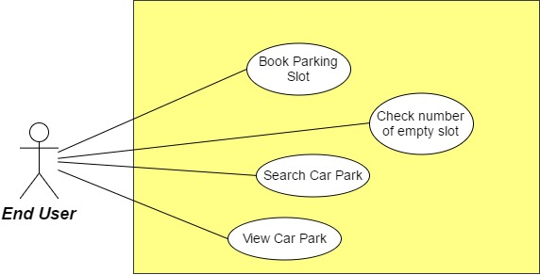

Figure : End User Use Case Diagram

|  |  |  |  |
| --- | --- | --- | --- |
| **Use Case-15 specification** | | | |
| **Use-case no.** | PGSS15 | **Use-case version** | 1.0 |
| **Use-case name** | Check number of empty slot | | |
| **Author** | Bui Phu Hiep | | |
| **Date** | 13/02/17 | **Priority** | High |
| **Actor:**   * End User   **Summary:**   * This use case allows user view number of empty slot in each car park   **Goal:**   * Show number of empty slot   **Triggers:**   * User login to the mobile application   **Preconditions:**   * Mobile application is already launch. * End user had logged in.   **Post Conditions:**   * **On Success:** User know the number of empty slot in car park * **On Failure:** Don’t show number of empty slot in car park   **Main Success Scenario:**   |  |  |  | | --- | --- | --- | | **No.** | **Actor Action** | **System Response** | | 1 | User log in to the application | Show the map with the marker as car park and the number, which indicate the number of empty slot |   **Alternative Scenario:**   * N/A   **Exceptions:**   * The number will have tick/ exclamation points to show that the number is recently update or not.   **Business Rules:**   * Tick: recently update * Exclamation points: number is not update in more than 1 hour. | | | |

|  |  |  |  |
| --- | --- | --- | --- |
| **Use Case-16 specification** | | | |
| **Use-case no.** | PGSS16 | **Use-case version** | 1.0 |
| **Use-case name** | Book parking slot | | |
| **Author** | Bui Phu Hiep | | |
| **Date** | 13/02/17 | **Priority** | High |
| **Actor:**   * End User   **Summary:**   * This use case allow user to book parking slot before go to the car park   **Goal:**   * Book the parking slot before go to car park   **Triggers:**   * User has selected the car park to book   **Preconditions:**   * Mobile application is already launch. * End user had logged in.   **Post Conditions:**   * **On Success:** User book the parking slot success * **On Failure:** Show error message when book   **Main Success Scenario:**   |  |  |  | | --- | --- | --- | | **No.** | **Actor Action** | **System Response** | | 1 | User log in to the application | Show the map with the marker as car park and the number, which indicate the number of empty slot | | 2 | User select the car park they want to book | Show the “Book” button if has empty slot | | 3 | Fill information for transaction  Click “Submit” | Make a transaction and set one parking slot to booked  Show the address of booked parking slot to the user |   **Alternative Scenario:**   * N/A   **Exceptions:**   * Transaction fail by 3rd party.   **Business Rules:**   * N/A | | | |

|  |  |  |  |
| --- | --- | --- | --- |
| **Use Case-17 specification** | | | |
| **Use-case no.** | PGSS17 | **Use-case version** | 1.0 |
| **Use-case name** | Search car park | | |
| **Author** | Bui Phu Hiep | | |
| **Date** | 13/02/17 | **Priority** | High |
| **Actor:**   * End User   **Summary:**   * This use case allow user to search a car park by name or address   **Goal:**   * Show the searched car park   **Triggers:**   * User login to the mobile application   **Preconditions:**   * Mobile application is already launch. * End user had logged in.   **Post Conditions:**   * **On Success:** Show the searched car park on the map if success * **On Failure:** Show message error   **Main Success Scenario:**   |  |  |  | | --- | --- | --- | | **No.** | **Actor Action** | **System Response** | | 1 | User log in to the application | Show the map with the marker as car park and the number, which indicate the number of empty slot | | 2 | Enter the name or address in the search bar  Press “Enter” or click “Search” | Find the car park base on name or address then focus on the map. |   **Alternative Scenario:**   |  |  |  | | --- | --- | --- | | **No.** | **Actor Action** | **System Response** | | 1 | User log in to the application | Show the map with the marker as car park and the number, which indicate the number of empty slot | | 2 | Enter the name or address in the search bar  Press “Enter” or click “Search” | Show message don’t have car park if the name or address is incorrect |   **Exceptions:**   * N/A   **Business Rules:**   * N/A | | | |

|  |  |  |  |
| --- | --- | --- | --- |
| **Use Case-18 specification** | | | |
| **Use-case no.** | PGSS18 | **Use-case version** | 1.0 |
| **Use-case name** | View Car Park | | |
| **Author** | Bui Phu Hiep | | |
| **Date** | 13/02/17 | **Priority** | High |
| **Actor:**   * End User   **Summary:**   * This use case allow user to view car park info.   **Goal:**   * User can view the information of car park.   **Triggers:**   * User select their car park.   **Preconditions:**   * Mobile application is already launch. * Manager has been logged in   **Post Conditions:**   * **On Success:** User can view the information of car park. * **On Failure:** Show error message   **Main Success Scenario:**   |  |  |  | | --- | --- | --- | | **No.** | **Actor Action** | **System Response** | | 1 | User select once car park | Show the car park detail information on mobile |   **Alternative Scenario:**   * N/A   **Exceptions:**   * N/A   **Business Rules:**   * N/A | | | |

## Software System Attribute

### Usability

* User controls all system components via only mobile application.
* The system can install easily.
* User can learn how to use the system fast.

### Reliability

### Availability

* The mechanical component requires electrical system to work well.
* Hardware components are easy to find in the market.

### Security

* Mobile application requires authentication and authorization implement well because manager and end user use the same application.

### Maintainability

* Use plug and play component so we can easily replace it.

### Portability

* Easy to construct.

### Performance

* Detection car is fast, less then 50ms.
* The speed of server can scale base on the budget easily.

## Conceptual Diagram



Figure 22: Conceptual Diagram

**Data Dictionary**

|  |  |
| --- | --- |
| **Entity Data dictionary: describe content of all entities** | |
| **Entity Name** | **Description** |
| CarPark | Descript all car park information in the system |
| Area | Describe all area detail in car park |
| ParkingLot | Describe parking lot information in the area |
| Item | Describe hardware item in each parking lot |
| BookingHistory | Describe the booking history of the user |
| Transaction | Save the transaction of each booking |

Table : Conceptual diagram data dictionary

# D. Software – Hardware Design Description

## Design Overview

This document describes the technical and user interface design of **PGSS.** It includes the architectural design, the detailed design of common functions and business functions and the design of database model.

The architectural design describes the overall architecture of the system and the architecture of each main component and subsystem.

The detailed design describes static and dynamic structure for each component and functions. It includes class diagrams, class explanations and sequence diagrams for each use case.

The database design describes the relationships between entities and details of each entity.

Document overview:

* Section 2: gives an overall description of the system architecture design.
* Section 3: gives component diagrams that describe the connection and integration of the system.
* Section 4: gives the detail design description which includes class diagram, class explanation, and sequence diagram to details the application functions.
* Section 5: describe screen design.
* Section 6: describe a fully attributed ERD.
* Section 7: describe algorithms.

## System Architectural Design

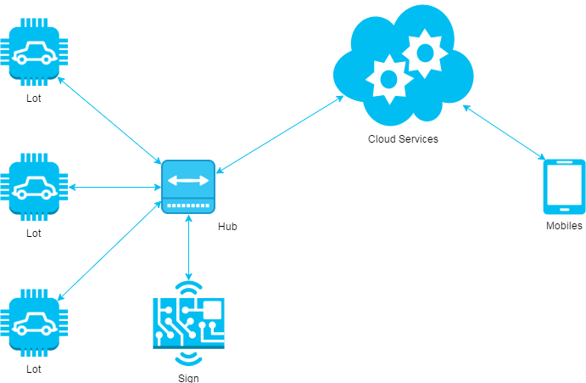

*Figure 23: System architecture design*

This diagram is referenced and modified from an original concept from: The Internet of Things: An Overview by The Internet Society (ISOC). In this device-to-gateway model, or more typically, the device-to-application-layer gateway (ALG) model, the IoT device connects through an ALG service as a conduit to reach a cloud service. The hub serves as a local gateway between individual IoT devices and a cloud service, but they can also bridge the interoperability gap between devices themselves.

### Hardware Program Architecture Description



Figure : Hardware Program architectural

**Parking Lot Node** is a device placed at each lot in the car park. It plays the role as a passive IoT node and controls other components, which connects to it through several kinds of port to perform various works:

**Arduino Nano**: plays the roles as central processing unit for IoT node.

**Magnetometer**: an instrument that measures magnetism, which is used as metal detectors to detect ferrous metals in a car.

**Servo**: a linear actuator that allows for precise control of angular or linear position, velocity and acceleration. This will be used to control the barrier in each lot.

**LED**: a RGB LED used as an Indicator LED in each lot.

**RF Module**: a small device used to transmit/receive radio signals between two devices. This is used to create a network bridge for the whole system.

**Sign Node** is a device placed at each area and at the entrance of the car park. It also a passive node and used to display the available lots in each area:

**Arduino Nano**: plays the roles as central processing unit for IoT node.

**RF Module**: a small device used to transmit/receive radio signals between two devices. This is used to create a network bridge for the whole system.

**LED:** a large LED display screen

**Hub** is a stand-alone gateway device that has RF Module installed to communicate with all other IoT nodes. It also connects to cloud service, allowing the user to gain access to the devices using a smartphone app and an Internet connection:

**Raspberry Pi**: plays the roles as central processing unit for Hub node.

**RF Module**: a small device used to transmit/receive radio signals between two devices. This is used to create a network bridge for the whole system.

**Network Interfaces:** an interfaces to connect to the Internet.

**API Service:** is a cloud service that provides all necessary APIs and database.

**Real time Service:** a cloud service that provides real time communication between smartphone app and Hub.

### Mobile Application Architecture Description

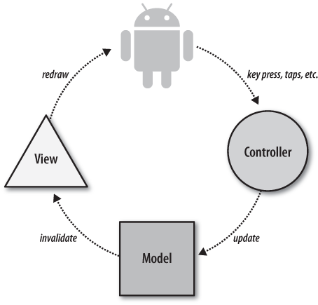

*Figure 25: Mobile Application architecture*

In Mobile Application, the system is developed under Standard Android Architecture. This is the default approach with layout files, Activities/Fragments acting as the controller and Models used for data and persistence. With this approach, Activities are in charge of processing the data and updating the views. Activities act like a controller in MVC but with some extra responsibilities that should be part of the view.

### Web API Architecture Description

Figure : Hardware - Software Connection Architecture Description

In Web API, the server is design under MVVM Patern

There are three core components in the MVVM pattern: the model, the view, and the view model. Each serves a distinct and separate role. The following illustration shows the relationships between the three components.



## Component Diagram

### General Component Diagram

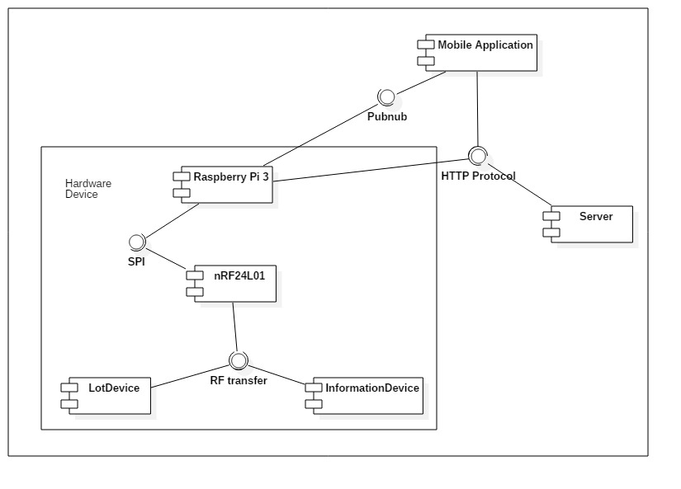

Figure : General Component Diagram

### Lot Device Diagram

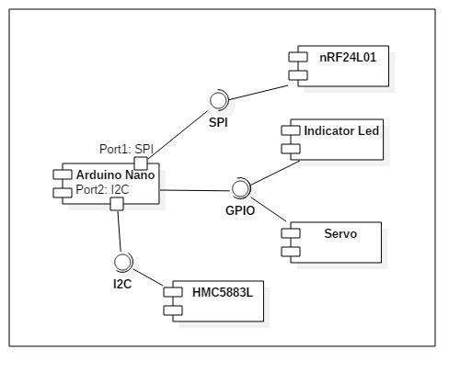

Figure : Lot Device Diagram

### Information Device Diagram

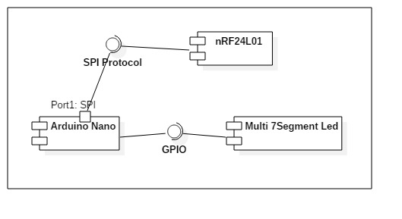

Figure : Information Device Diagram

### Server Diagram

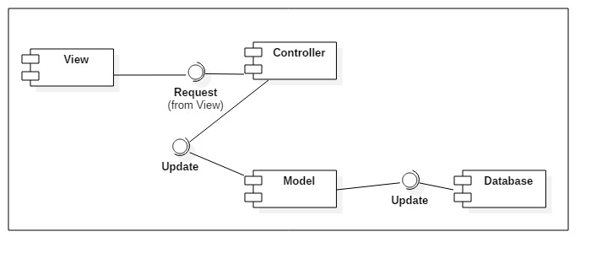

Figure : Server Diagram

### Component Dictionary

|  |  |
| --- | --- |
| Component Dictionary: Describes components | |
| **Mobile Application** | The application for user on android devices |
| **Server** | The Web API server, which make the interaction between the Raspberry Pi and the Mobile Application. It also save information to the database. |
| **Raspberry Pi 3** | The main controller in the hardware system that control all Lot Device and Information Device in each car park. |
| **Lot Device** | The device in each parking lot that control the indicator led, servo and use the magnetometer sensor to detect car. |
| **Information Device** | The number led board that show the number of empty lot in each area and number of empty lot in car park. |
| **nRF24L01** | The RF module, which help main controller, lot device and information device interact with each other. |
| **Arduino Nano** | The controller in lot device and information device. |
| **Indicator Led** | The RGB led to show the status of parking lot (empty, in used, reserved, disabled). |
| **Servo** | The barrier to prevent other car get in the parking lot when it is reserved. |
| **HMC5883L** | The magnetometer sensor to realize if the metal is near. |
| **Pubnub** | The third party API that help real time interaction. |
| **HTTP Protocol** | A transfer protocol to interact between server, mobile application and Raspberry Pi 3. |
| **SPI** | Synchronous serial communication interface used for short distance communication. |
| **I2C** | The inter-integrated circuit to communicate between arduino and magnetometer sensor. |
| **GPIO** | The communication between Arduino and led, servo, … |
| **Multi 7-Segment Led** | The 7 segment led to indicate number. |
| **View** | The JSON result of the API controller. |
| **Controller** | The API controller in the server. |
| **Model** | The entity model. |
| **Database** | The collection of data. |

Table : Component dictionary

## Detailed Description

### Web API Detailed Description

#### Class Diagram

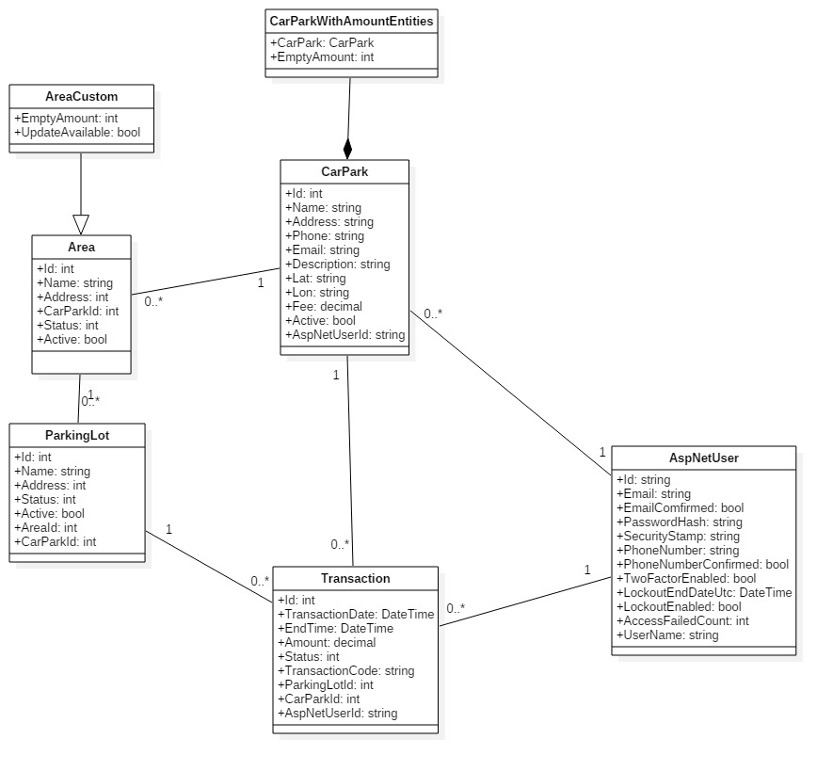

Figure : Model Class Diagram

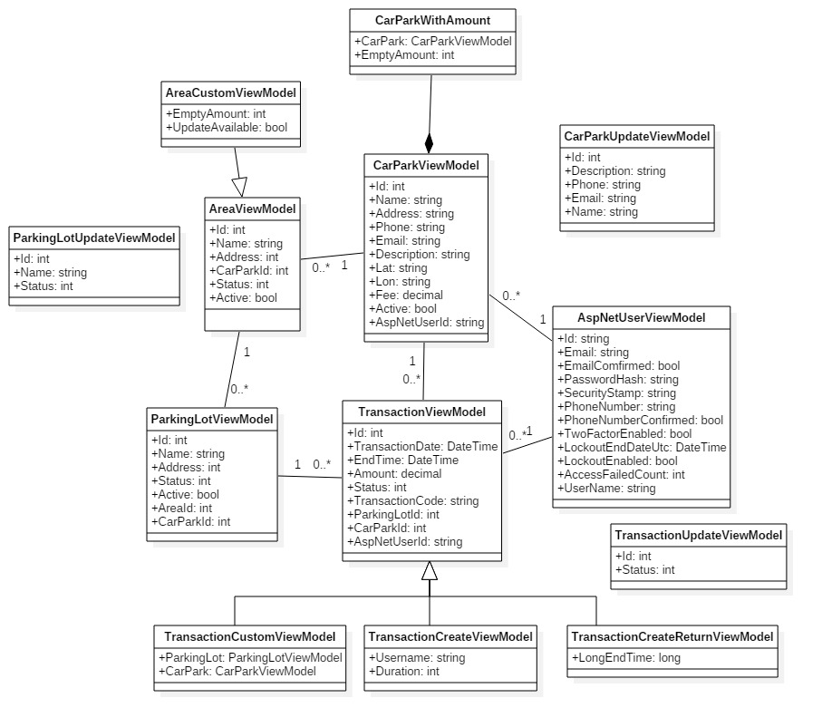

Figure : View Model Class Diagram

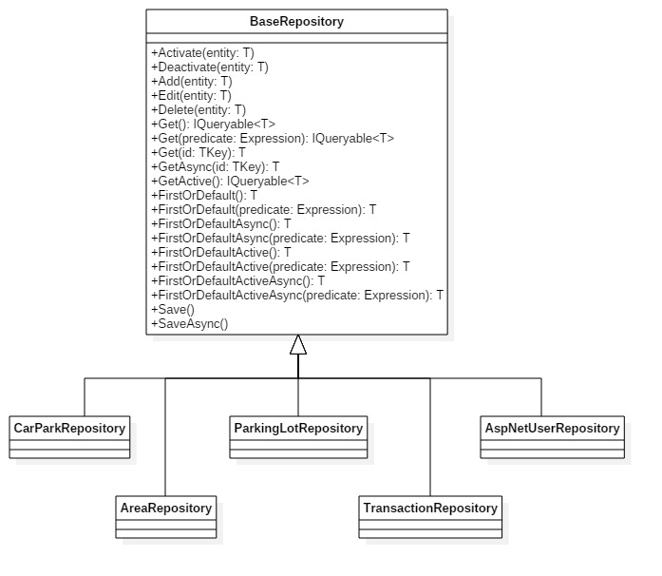

Figure : Repository Class Diagram

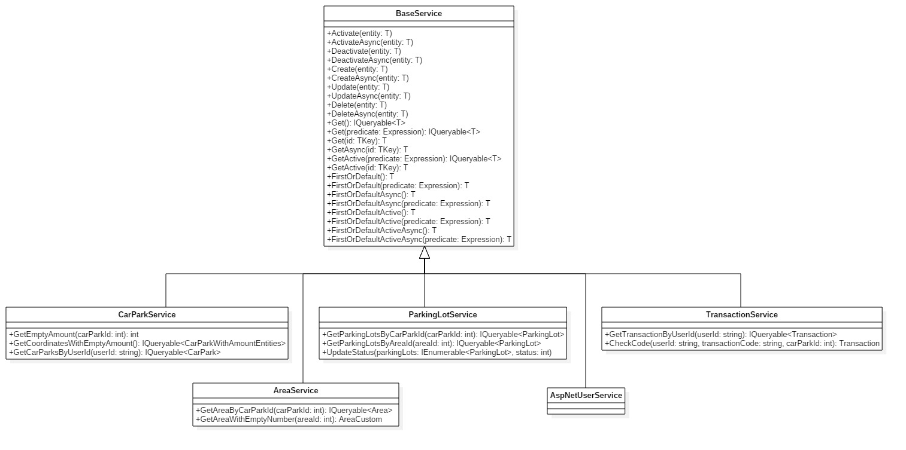

Figure : Service Class Diagram

#### Class Diagram Explanation

*References to main document, Section D – 4.1.2. Class Diagram Explanation*

#### Interaction Diagram

##### Register

**Summary:** This diagram shows the process to create a new user.

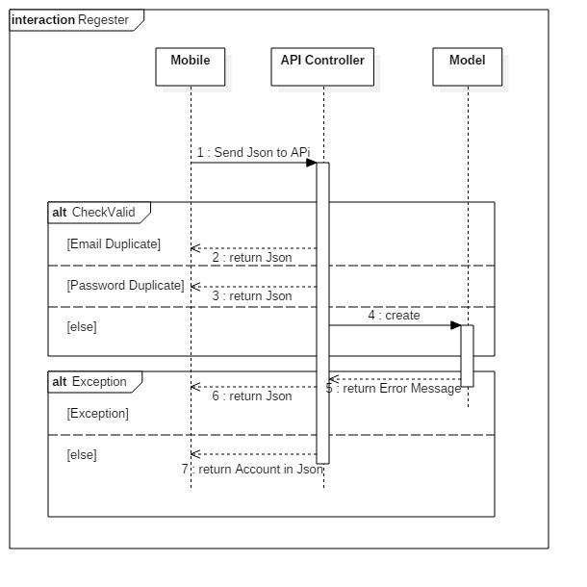

Figure : Register Diagram

##### Login

**Summary:** This diagram shows the process to authenticate the user on the server when they login on mobile

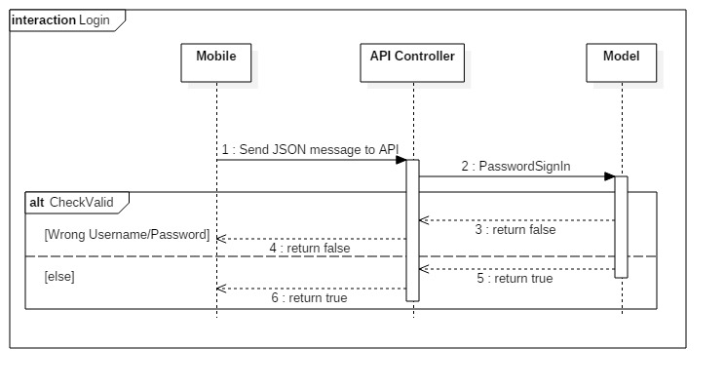

Figure : Login Diagram

##### Get Car Park

**Summary:** This diagram shows the process to get the list of available car park and return to the mobile application.

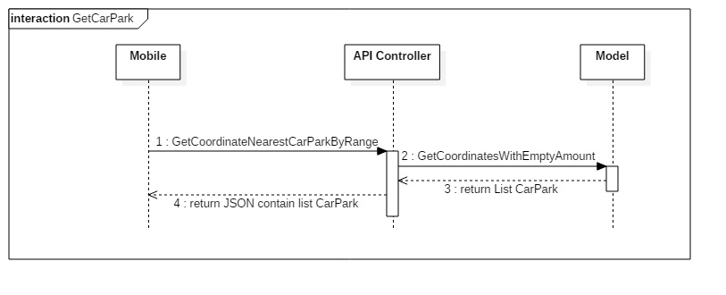

Figure : GetCarPark Diagram

##### Get Area

**Summary:** This diagram shows the process to get the list of available area in selected car park

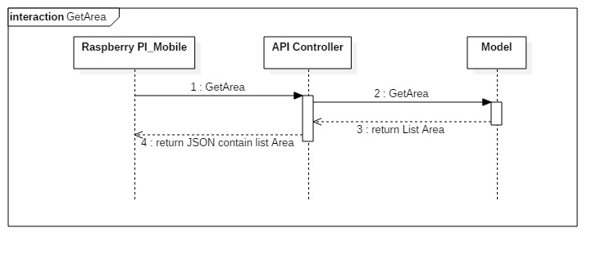

Figure : GetArea Diagram

##### Get Parking Lot

**Summary:** This diagram shows the process to get the list of available parking lot in selected car park

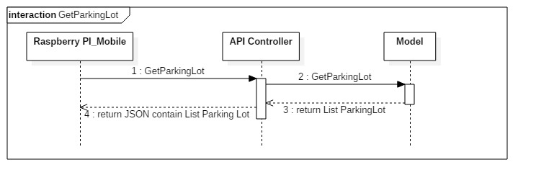

Figure : GetParkingLot Diagram

##### Update Area

**Summary:** This diagram shows the process to update the status/name of an area. If area has the lot in use, it will not be updated.

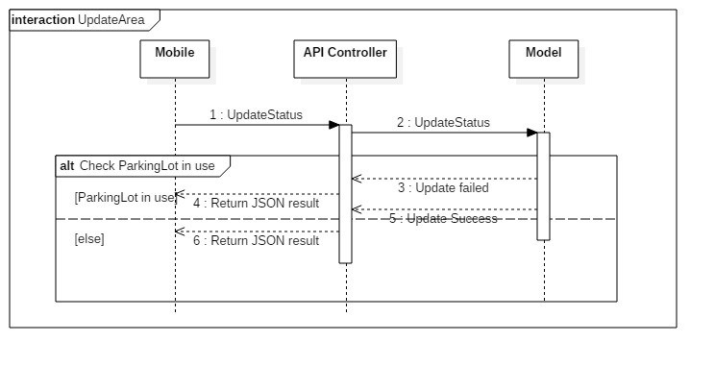

Figure : UpdateArea Diagram

##### Update Parking Lot

**Summary:** This diagram shows the process to update the status/name of a parking lot. If selected parking lot is in use, it will not be updated.

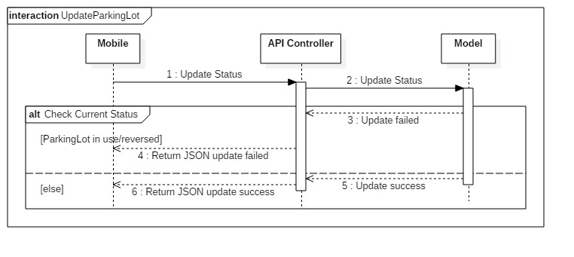

Figure : UpdateParkingLot Diagram

##### Update List Status Parking Lot

**Summary:** This diagram shows the process to update the status/name of a list of area. If once parking lot is in used, it will not be update.

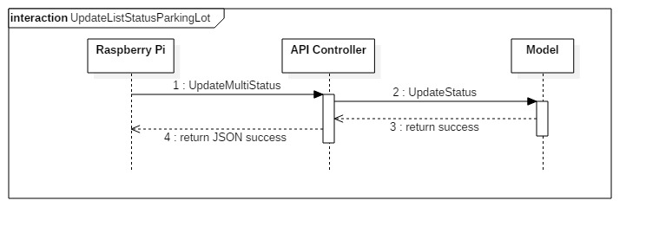

Figure : UpdateListStatusParkingLot Diagram

### Mobile Detailed Description

#### Class Diagram

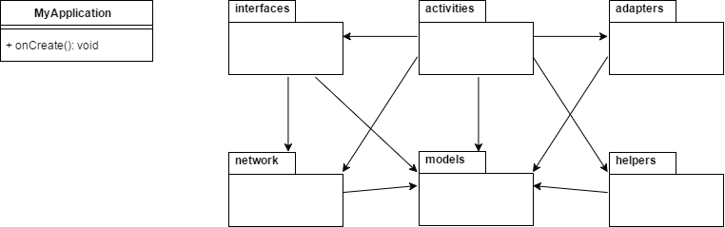

Figure : Main class diagram and package view

| **Packages Dictionary: describe packages** | |
| --- | --- |
| **Package Name** | **Description** |
| Interfaces | Package that provides interfaces for API communication |
| Activities | Package that provides all activities for Mobile Application |
| Adapters | Package that provides adapters for Recycler View / List View / Info Window |
| Network | Package that provides network models and network classes |
| Models | Package that provides all models |
| Helpers | Package that provides all helper class for database, network, pubnub… |

Table : Packages dictionary

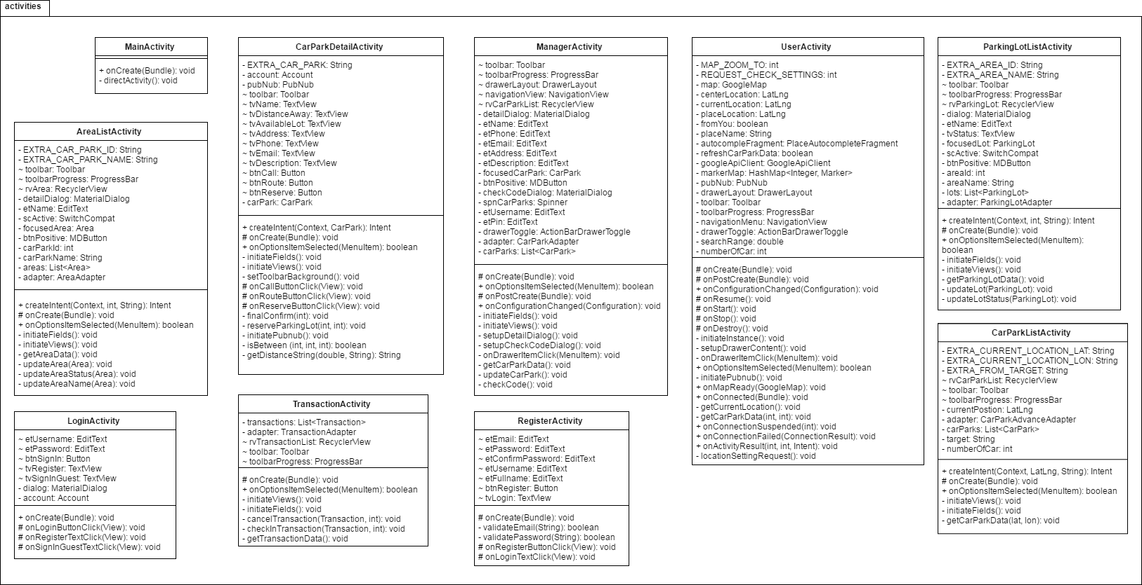

Figure : Activities package class diagram

| **Class Dictionary: describes class** | |
| --- | --- |
| **Class Name** | **Description** |
| MainActivity | Activity to handle direction of activity flow when app start |
| CarParkDetailActivity | Activity to provide detail information of car park and to handle request from user |
| ManagerActivity | Activity to provide manager with car parks information and to handle commands |
| AreaListActivity | Activity to provide list of areas in car park and handle commands |
| ParkingLotListActivity | Activity to provide list of parking lots in area and handle commands |
| LoginActivity | Activity to handle login request of user |
| RegisterActivity | Activity to handle register request of user |
| UserActivity | Activity to provide user with car parks information in map view and handle commands and directions to other activities |
| CarParkListActivity | Activity to provide user with car parks information in list view and handle commands |
| TransactionActivity | Activity to provide user with list of history transactions and handle commands |

Table : Activities package class dictionary

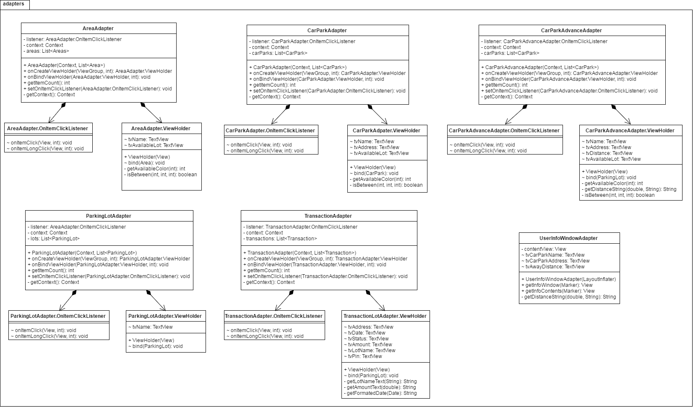

Figure : Adapters package class diagram

| **Class Dictionary: describes class** | |
| --- | --- |
| **Class Name** | **Description** |
| AreaAdapter | Provides a binding from Area data set to views that are displayed within a Recycler View |
| AreaAdapter  .OnItemClickListener | Interface definition for a callback to be invoked when an item in AreaAdapter has been click |
| AreaAdapter  .ViewHolder | Describes an item view and metadata about its place within the Recycler View |
| CarParkAdapter | Provides a binding from Car Park data set to views that are displayed within a Recycler View |
| CarParkAdapter  .OnItemClickListener | Interface definition for a callback to be invoked when an item in CarParkAdapter has been click |
| CarParkAdapter  .ViewHolder | Describes an item view and metadata about its place within the Recycler View |
| ParkingLotAdapter | Provides a binding from Parking Lot data set to views that are displayed within a Recycler View |
| ParkingLotAdapter  .OnItemClickListener | Interface definition for a callback to be invoked when an item in ParkingLotdapter has been click |
| ParkingLotAdapter  .ViewHolder | Describes an item view and metadata about its place within the Recycler View |
| CarParkAdvanceAdapter | Provides a binding from Car Park Advance data set to views that are displayed within a Recycler View |
| CarParkAdvanceAdapter  .OnItemClickListener | Interface definition for a callback to be invoked when an item in CarParkAdvanceAdapter has been click |
| CarParkAdvanceAdapter  .ViewHolder | Describes an item view and metadata about its place within the Recycler View |
| TransactionAdapter | Provides a binding from Transaction data set to views that are displayed within a Recycler View |
| TransactionAdapter  .OnItemClickListener | Interface definition for a callback to be invoked when an item in TransactionAdapter has been click |
| TransactionAdapter  .ViewHolder | Describes an item view and metadata about its place within the Recycler View |
| UserInfoWindowAdapter | Provides views for customized rendering of info windows |

Table : Adapters package class dictionary

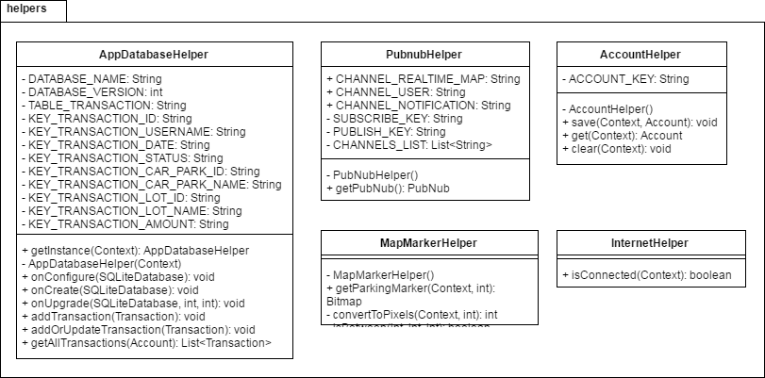

Figure : Helpers package class diagram

| **Class Dictionary: describes class** | |
| --- | --- |
| **Class Name** | **Description** |
| AppDatabaseHelper | A helper class provides API to work with SQLite |
| PubnubHelper | A helper class provides API to work with PubNub |
| AccountHelper | A helper class provides API to work with account data in shared preferences |
| MapMarkerHelper | A helper class provides utility for Google Map Marker |
| InternetHelper | A helper class provides utility for network |

Table : Helpers package class dictionary

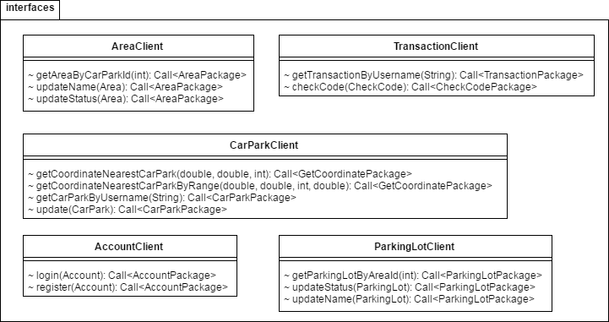

Figure : Interfaces package class diagram

| **Class Dictionary: describes class** | |
| --- | --- |
| **Class Name** | **Description** |
| AreaClient | An interface to consume API call for Area |
| TransactionClient | An interface to consume API call for Transaction |
| CarParkClient | An interface to consume API call for Car Park |
| AccountClient | An interface to consume API call for Account |
| ParkingLotClient | An interface to consume API call for Parking Lot |

Table : Interfaces package class dictionary

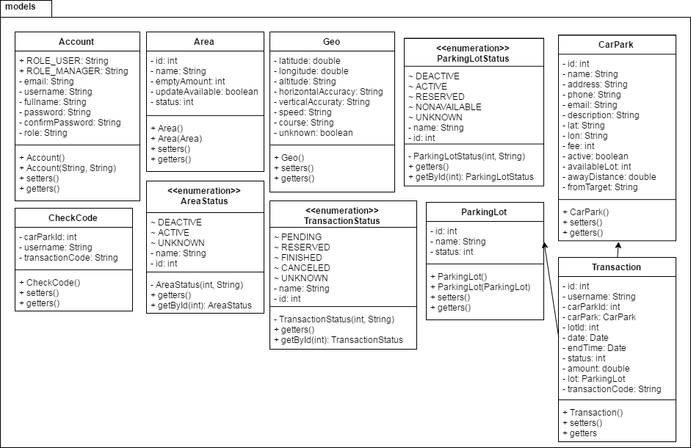

Figure : Models package class diagram

| **Class Dictionary: describes class** | |
| --- | --- |
| **Class Name** | **Description** |
| Account | Contain the account information |
| Area | Contain the area information |
| CheckCode | Contain the check code information |
| Geo | Contain the geo information |
| CarPark | Contain the car park information |
| Transaction | Contain the transaction information |
| ParkingLot | Contain the parking lot information |
| TransactionStatus | An enumeration contains the status of transaction |
| AreaStatus | An enumeration contains the status of area |
| ParkingLotStatus | An enumeration contains the status of parking lot |

Table : Models package class dictionary

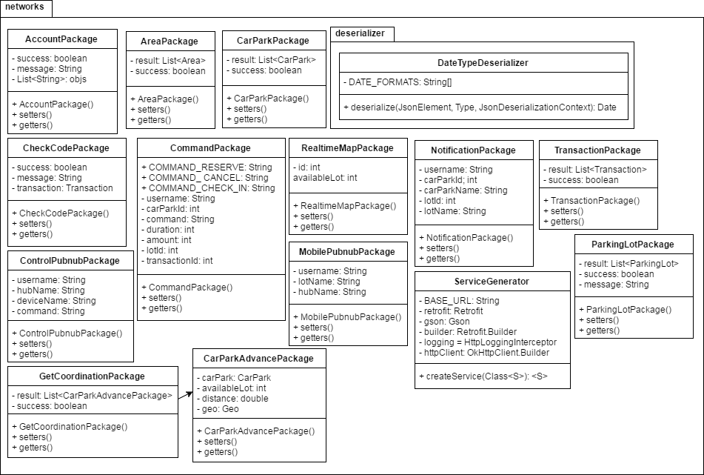

Figure : Networks package class diagram

| **Class Dictionary: describes class** | |
| --- | --- |
| **Class Name** | **Description** |
| AccountPackage | Contain the account information used in network |
| AreaPackage | Contain the area information used in network |
| CarParkPackage | Contain the car park information used in network |
| CheckCodePackage | Contain the check code information used in network |
| CommandPackage | Contain the command information used in network |
| RealtimeMapPackage | Contain the realtime map information used in network |
| ControlPubnubPackage | Contain the control pubnub information used in network |
| MobilePubnubPackage | Contain the mobile pubnub information used in network |
| GetCoordinationPackage | Contain the get coordination information used in network |
| CarParkAdvancePackage | Contain the car park advance information used in network |
| NotificationPackage | Contain the notification information used in network |
| TransactionPackage | Contain the transaction information used in network |
| ParkingLotPackage | Contain the parking lot information used in network |
| ServiceGenerator | A generator to generate retrofit service with interfaces |
| DateTypeDeserializer | A deserializer that can deserialize multiple type of Date format in json |

Table : Networks package class dictionary

#### Class Diagram Explanation

*References to main document, Section D – 4.2.2. Class Diagram Explanation*

#### Interaction Diagram

##### Load car parks on map

**Summary:** This diagram shows the process of app loads car parks data from API server and display them on map as marker, and update their available lots in real time.

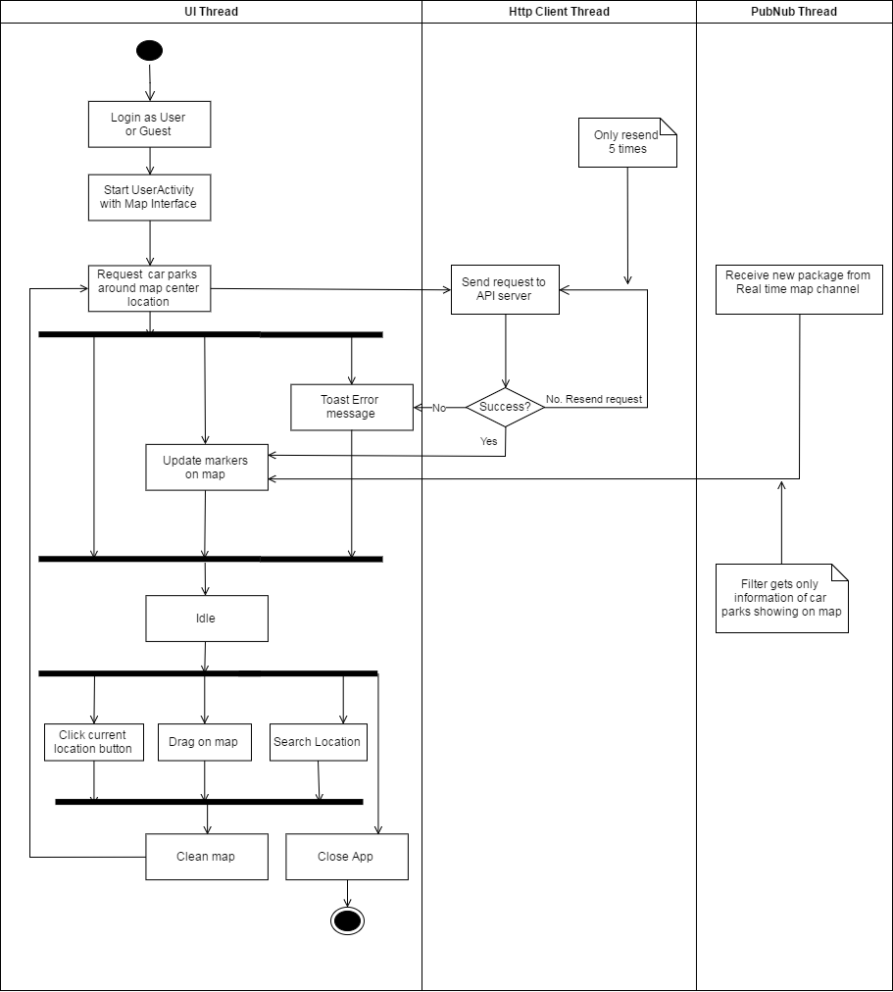

Figure : Interaction diagram - Load car parks on map

##### Load car parks in list

**Summary:** This diagram shows the process of app loads car parks data from API server and display them in list format, and update their available lots in real time.

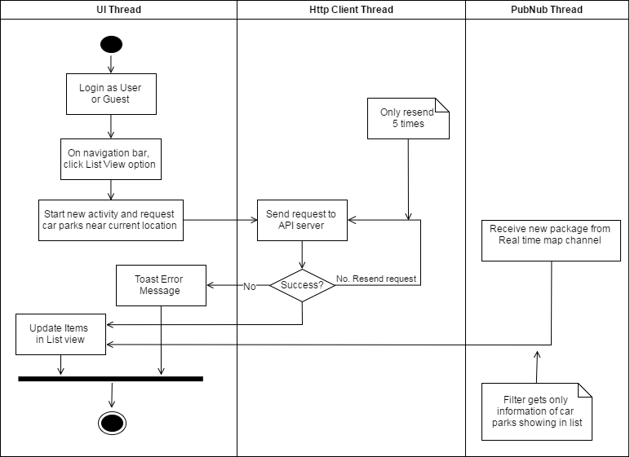

Figure : Interaction diagram - Load car parks in list

##### Car park detail information

**Summary:** This diagram shows the process of app loads car park detail information from API server and display it, update its available lots in real time and other action user can perform on the detail page.

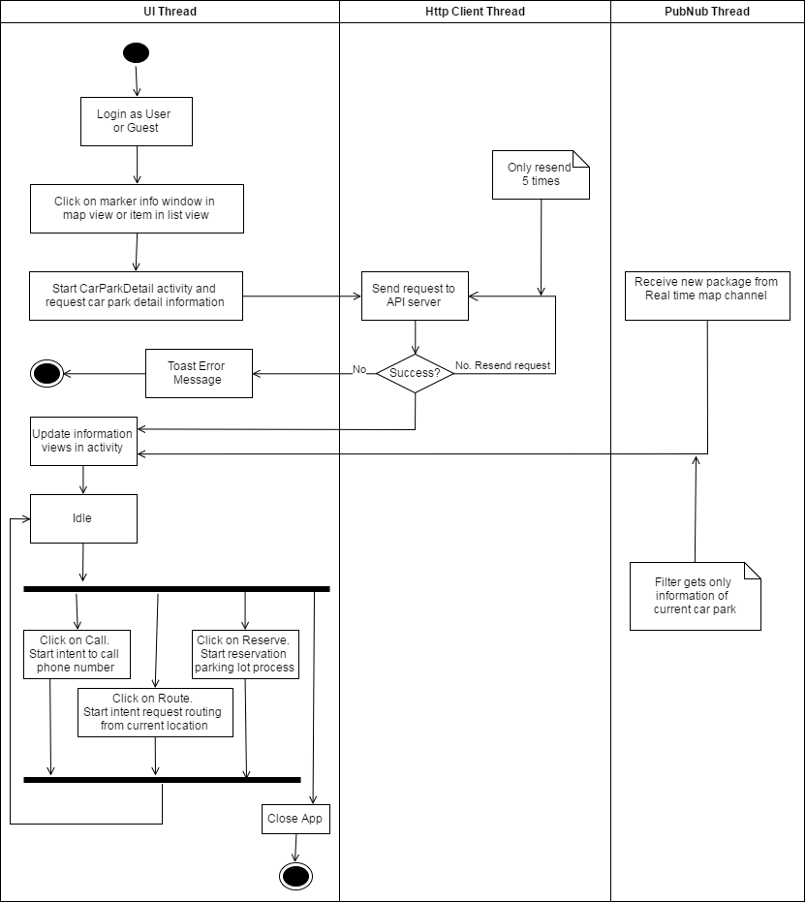

Figure : Interaction diagram - Car park detail information

##### Reserve parking lot process

**Summary:** This diagram shows the process of reserving parking lot, and receive notification about the reservation.

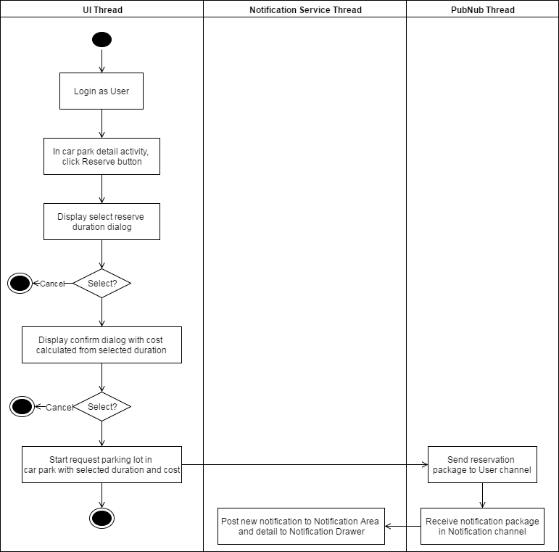

Figure : Interaction diagram - Reserve parking lot process

##### Transaction controller

**Summary:** This diagram shows the process of getting all transactions of user from API server and perform check-in, cancel process.

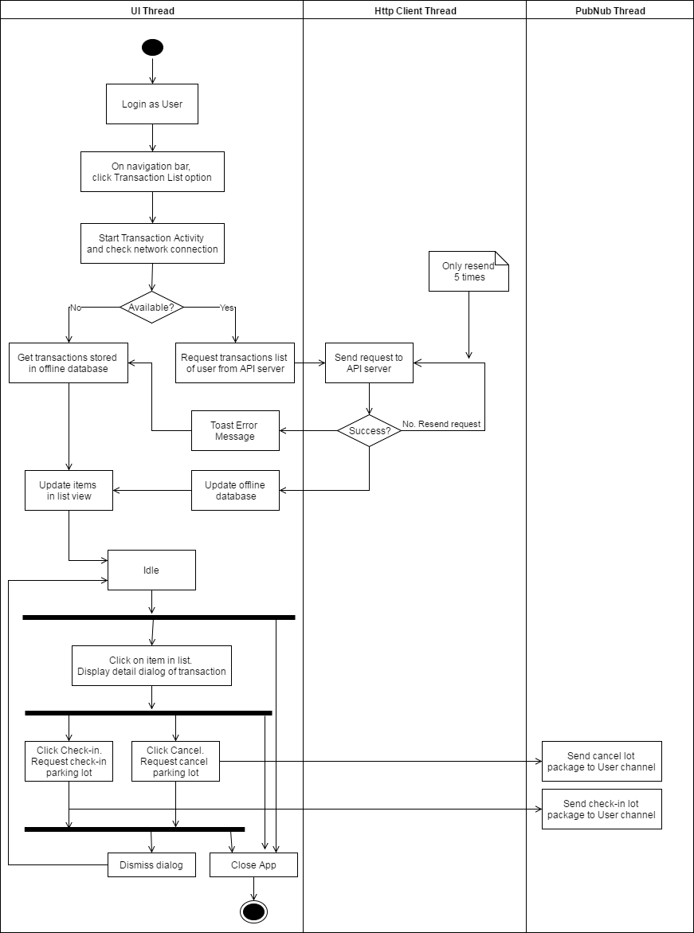

Figure : Interaction diagram - Transaction controller

##### Manage car parks

**Summary:** This diagram shows the process of app loads car parks from API server and display them in list from, update their available lots in real time, manage information and update to server and hub.

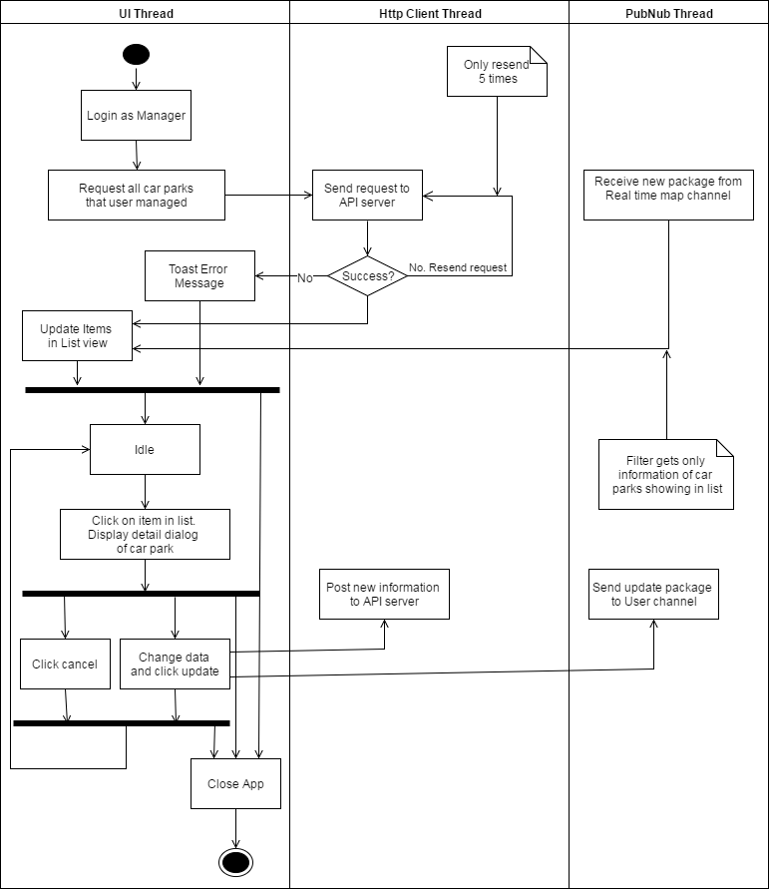

Figure : Interaction diagram - Manage car parks

##### Manage areas

**Summary:** This diagram shows the process of app loads areas from API server and display them in list from, manage information and update to server and hub.

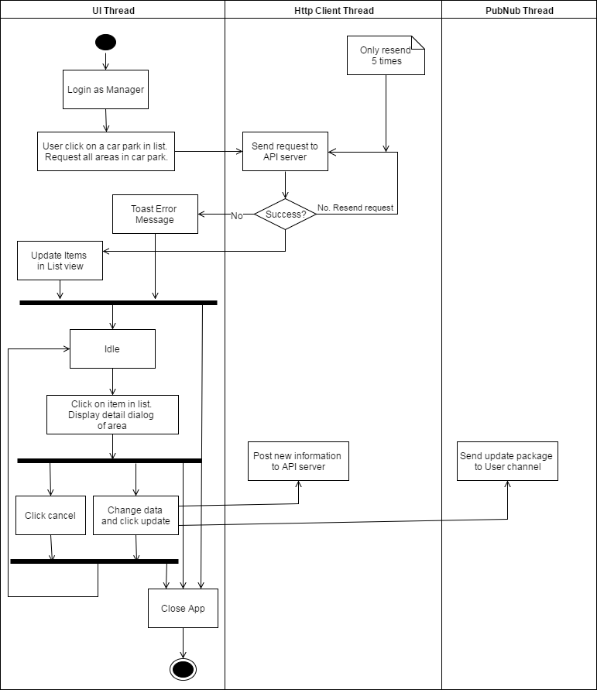

Figure : Interaction diagram - Manage areas

##### Manage parking lots

**Summary:** This diagram shows the process of app loads parking lot from API server and display them in list from, manage information and update to server and hub.

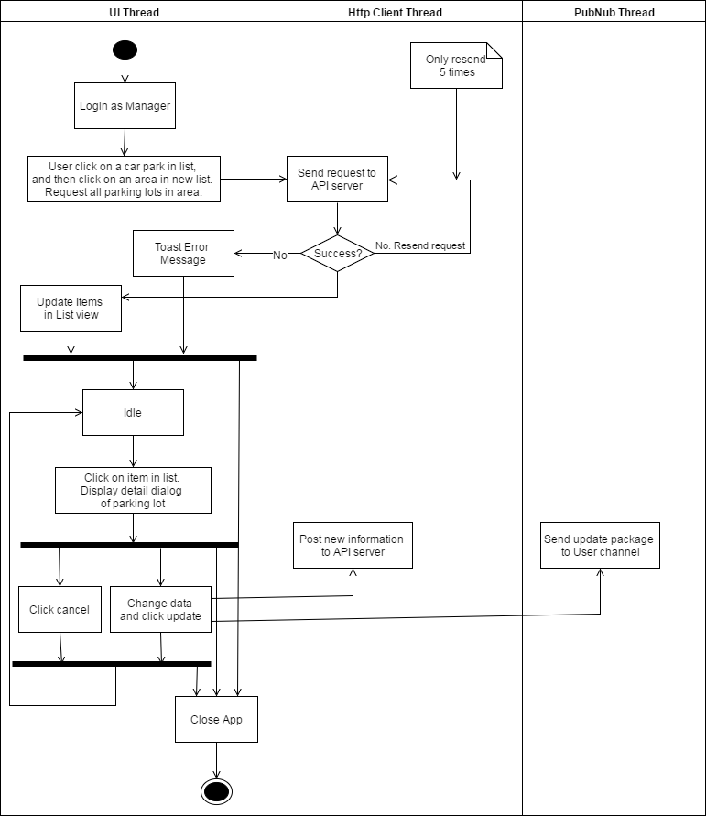

Figure : Interaction diagram - Manage parking lots

##### Check reservation PIN code

**Summary:** This diagram shows the process of how manager of car park can help user check-in their reservation.

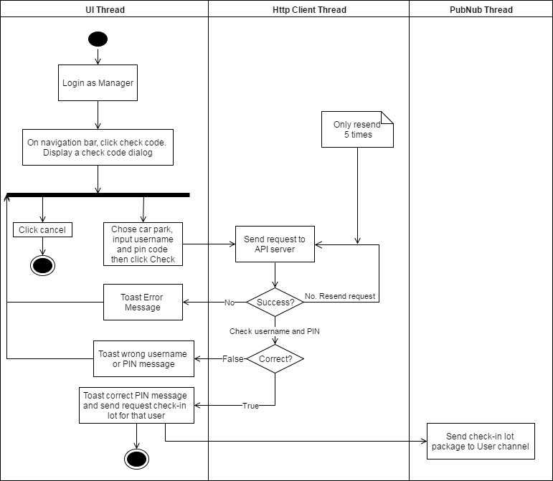

Figure : Interaction diagram - Check reservation PIN code

### Embedded Program Detailed Description

#### Class Diagram

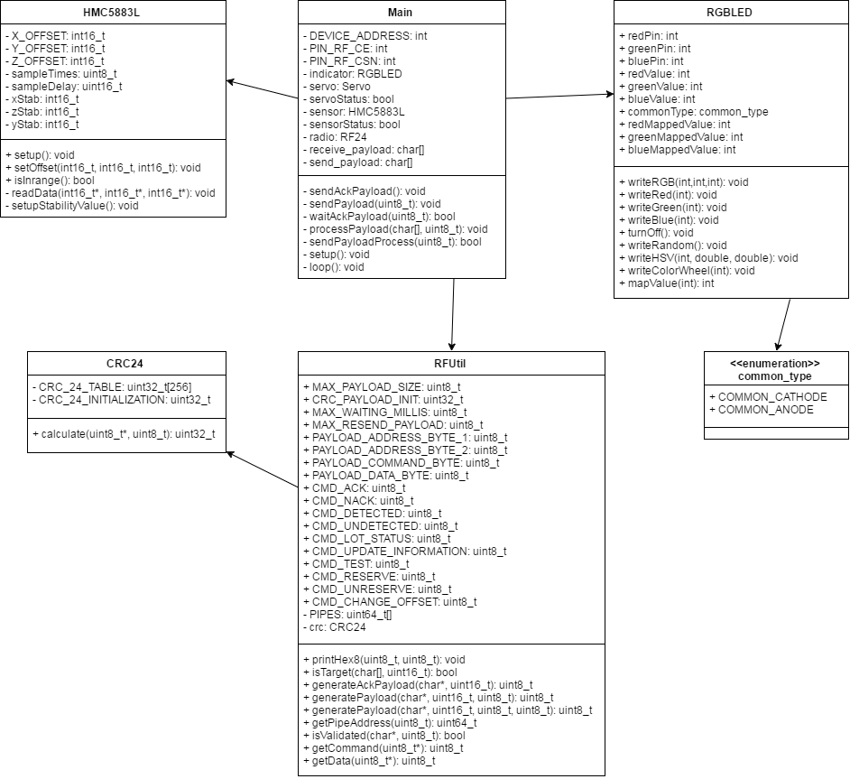

Figure : Lot node class diagram

| **Class Dictionary: describes class** | |
| --- | --- |
| **Class Name** | **Description** |
| Main | Core program of node |
| RFUtil | Contain necessary information and methods support RF module |
| CRC24 | Contain the checksum method for RFUtil |
| HMC5883L | Provides methods to use the magnetometer |
| RGBLED | Provides methods to control LED RGB |
| common_type | Enumeration contains type of LED RGB |

Table : Lot node class dictionary

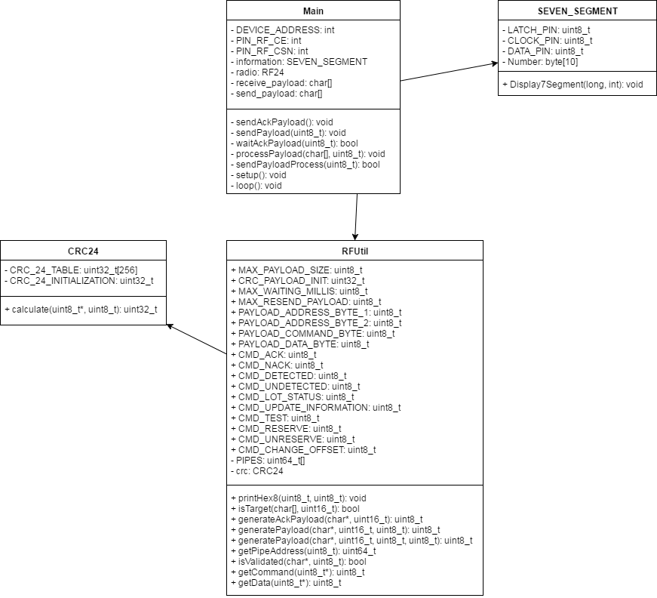

Figure : Sign node class diagram

| **Class Dictionary: describes class** | |
| --- | --- |
| **Class Name** | **Description** |
| Main | Core program of node |
| RFUtil | Contain necessary information and methods support RF module |
| CRC24 | Contain the checksum method for RFUtil |
| SEVEN_SEGMENT | Provide methods to use 7-segments sign |

Table : Sign node class dictionary

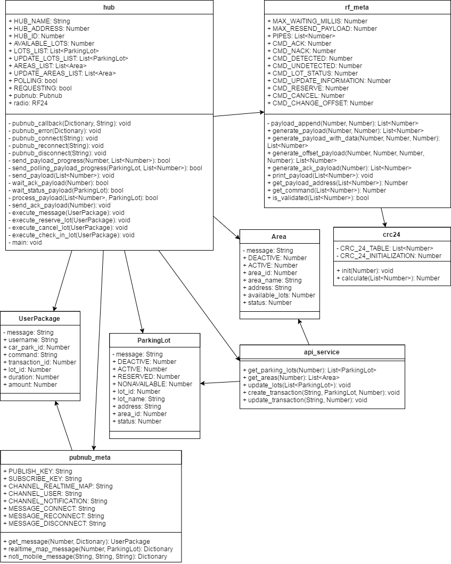

Figure : Hub class diagram

| **Class Dictionary: describes class** | |
| --- | --- |
| **Class Name** | **Description** |
| hub | Main program of Hub |
| rf_meta | Contain information and necessary methods for RF |
| crc24 | Contain the checksum method for rf_meta |
| ParkingLot | Information of parking lot |
| Area | Information of area |
| UserPackage | Information of user message in PubNub |
| api_service | Contain methods for API service |
| pubnub_meta | Contain methods for PubNub service |

Table : Hub class dictionary

#### Class Diagram Explanation

*References to main document, Section D – 4.3.2. Class Diagram Explanation*

#### Interaction Diagram

##### Lot node process

**Summary:** This diagram shows the process of the MCU in lot node detects car, transmits and receives data from RF network and controls other actuator.

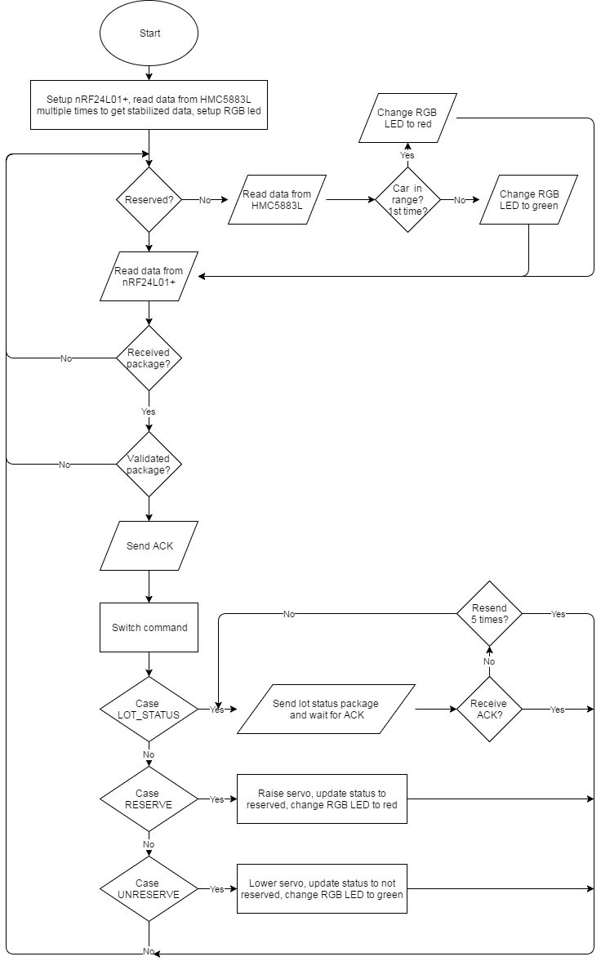

Figure : Interaction diagram - Lot node process

##### Sign node process

**Summary:** This diagram shows the process of the MCU in sign node transmits and receives data from RF network and controls led board.

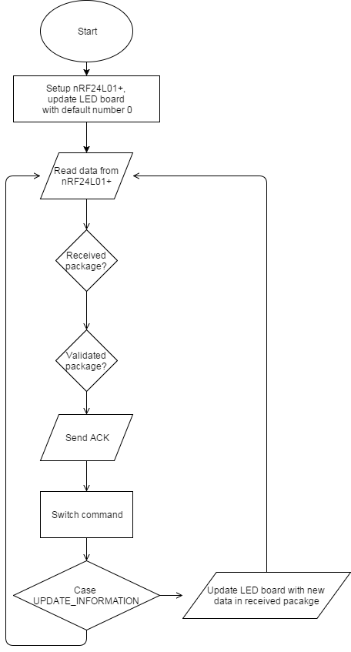

Figure : Interaction diagram - Sign node

##### Hub polling process

**Summary:** This diagram shows the process of the hub performs polling to get new data from lot nodes, update sign nodes if necessary, send updated information to API server and PubNub server

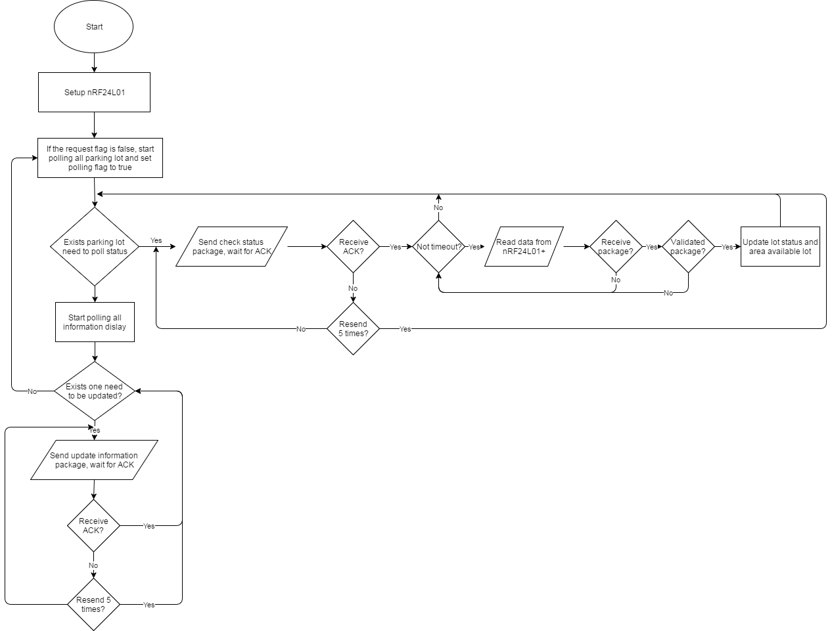

Figure : Interaction diagram - Hub polling process

##### Hub execute request process

**Summary:** This diagram shows the process of the hub receives requests from PubNub server and execute them.

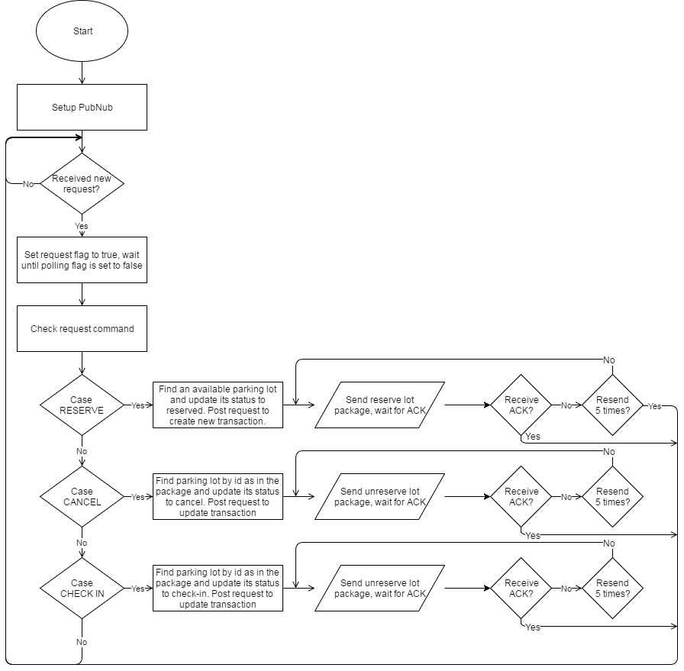

Figure : Interaction diagram - Hub request process

### Hardware Detailed Description

#### Raspberry Pi 3 model B

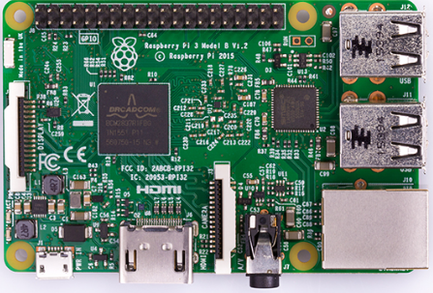

Figure : Raspberry Pi 3 model B

The Raspberry Pi 3 is the third generation Raspberry Pi. It replaced the Raspberry Pi 2 Model B in February 2016.

The Raspberry Pi 3 is a low cost, credit-card size computer that includes 802.11n Wi-Fi and Bluetooth 4.1. Even though it requires lots of additional hardware to function as a full PC with limited operating system selection, with the introduction of wireless connectivity and a boost in performance over its previous iteration, make the Raspberry Pi 3 Model B appropriate for a wider variety of projects – and it still costs just $35.

For our project, the Raspberry Pi 3 will be use as the Hub for IoT architecture. It will perform as a Gateway to connect the system to cloud server. The Hub will need to polling the information from Lot node continuously while waiting for User/Manager request on the cloud so the power to run multi-thread, coupled with build-in Wi-Fi and low cost is the main reason we use this device.

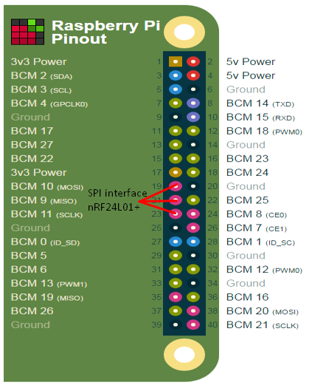

Figure : Raspberry Pi 3 Model B pinount

On the Raspberry Pi 3 we use Python 3 to build program. We use build-in libraries such as: GPIO, time, system… for information about our custom libraries and modules, please refer to previous section 4.3.

#### Arduino Nano

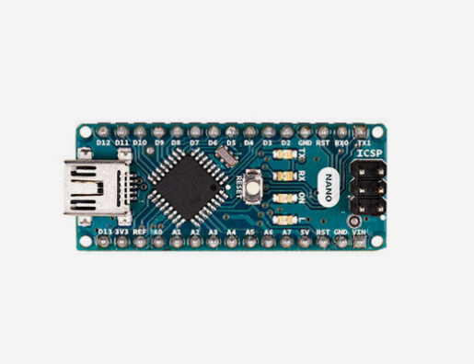

Figure : Arduino Nano

Arduino Nano is a surface mount breadboard embedded version with integrated USB. It is a small, complete, and breadboard-friendly board based on ATmega328 (Arduino Nano 3.x).

**POWER**:

The Arduino Nano can be powered via the mini-B USB connection, 6-20V unregulated external power supply (pin 30), or 5V regulated external power supply (pin 27). The power source is automatically selected to the highest voltage source.

**PINOUT:**

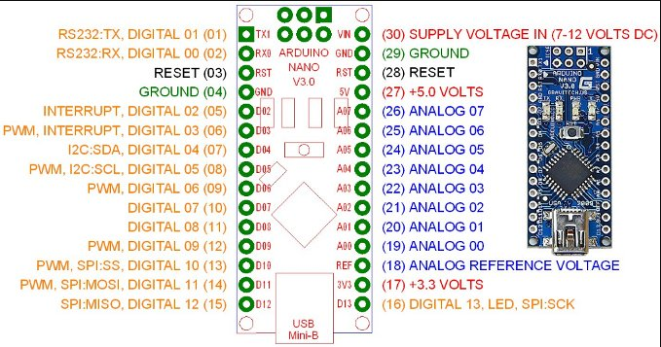

Figure : Arduino Nano pinout

In each Lot node and Sign node, we need a MCU to handling information from sensor, RF module and control other actuators. Arduino Nano is perfect for our need because of its power to run code, small size, low cost and easy to implement.

On Arduino Nano we use build-in libraries for I2C, SPI interface and our custom libraries and modules. For more information about our custom libraries and modules, please refer to previous section 4.3.

#### Compass module 3-Axis HMC5883L

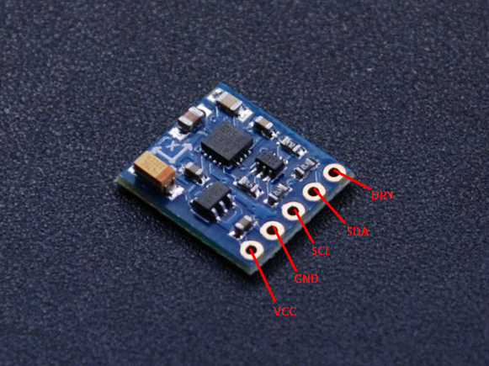

Figure : 3-Axis HMC5883L

The Honeywell HMC5883L is a surface-mount, multi-chip module designed for low-field magnetic sensing with a digital interface for applications such as low cost compassing and magnetometry.

We will place this sensor right at the middle of parking lot so it will detect if a car is parked in that lot or not. In theory, this magnetometer can detect the distorted flux line of earth’s field created when it being cut by a large metallic body (ferrous) of the car. We have proved this test in a separated report (Test HMC5883L.xlxs) that the module provides noticeable offset, in other words, the car can be detected.

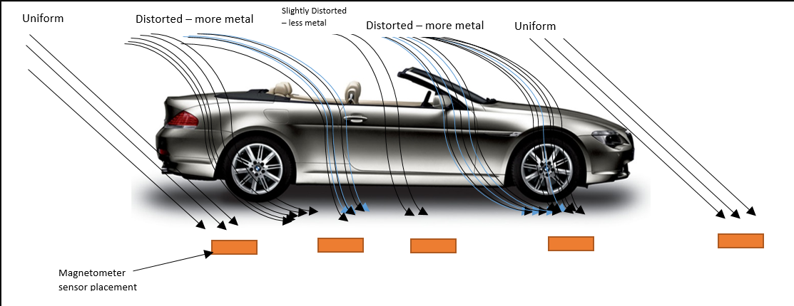

Figure : Earth’s magnetic field lines distorted by ferrous metal of the car

**PINOUT:**

* **VIN:** this is the power in pin, give it 3-5VDC. It is reverse-polarity protected. Use the same voltage as you do for the controlling microcontroller's logic.
* **GND:** this is the common power and data ground pin.
* **SDA** and **SCL:** these are the I2C data and clock pins used to send and receive data from the module to your microcontroller. There are 10K pull-ups on these pins to the VIN pin. You can connect these pins to 5V I2C lines, there are level shifters on board to safely bring the pins down to 3V.
* **RDY:** this is the 'data ready' pin output. If you want to stream data at high speed (higher than 100 times a second) you may want to listen to this pin for when data is ready to be read.

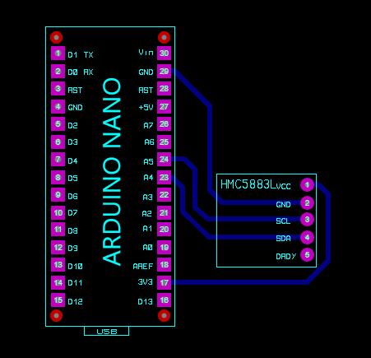

Figure : Arduino Nano and HMC5883L connection

**ANISOTROPIC MAGNETO-RESISTIVE SENSORS**

The Honeywell HMC5883L magneto-resistive sensor circuit is a trio of sensors and application specific support circuits to measure magnetic fields. With power supply applied, the sensor converts any incident magnetic field in the sensitive axis directions to a differential voltage output. The magneto-resistive sensors are made of a nickel-iron (permalloy) thin-film and patterned as a resistive strip element. In the presence of a magnetic field, a change in the bridge resistive elements causes a corresponding change in voltage across the bridge outputs.

These resistive elements are aligned together to have a common sensitive axis (indicated by arrows in the pinout diagram) that will provide positive voltage change with magnetic fields increasing in the sensitive direction. Because the output is only proportional to the magnetic field component along its axis, additional sensor bridges are placed at orthogonal directions to permit accurate measurement of magnetic field in any orientation.

**MODES OF OPERATION**

* **Continuous-Measurement Mode:** the device continuously makes measurements, at user selectable rate, and places measured data in data output registers.
* **Single-Measurement Mode:** this is the default power-up mode. During single-measurement mode, the device makes a single measurement and places the measured data in data output registers. After the measurement is complete and output data registers are updated, the device is placed in idle mode.
* **Idle Mode:** during this mode the device is accessible through the I2C bus, but major sources of power consumption are disabled, such as, but not limited to, the ADC, the amplifier, and the sensor bias current. All registers maintain values while in idle mode. The I2C bus is enabled for use by other devices on the network while in idle mode.

**REGISTER LIST**

|  |  |  |
| --- | --- | --- |
| **Address Location** | **Name** | **Access** |
| 00 | Configuration Register A | Read/Write |
| 01 | Configuration Register B | Read/Write |
| 02 | Mode Register | Read/Write |
| 03 | Data Output X MSB Register | Read |
| 04 | Data Output X LSB Register | Read |
| 05 | Data Output Z MSB Register | Read |
| 06 | Data Output Z LSB Register | Read |
| 07 | Data Output Y MSB Register | Read |
| 08 | Data Output Y LSB Register | Read |
| 09 | Status Register | Read |
| 10 | Identification Register A | Read |
| 11 | Identification Register B | Read |
| 12 | Identification Register C | Read |

Table : HMC55883L Register list

**IMPLEMENT:**

We implemented the usage of this magnetometer in C++ code in a module name HMC5883L, which can be refer in previous section 4.3 for more information.

#### RF module nRF24L01+

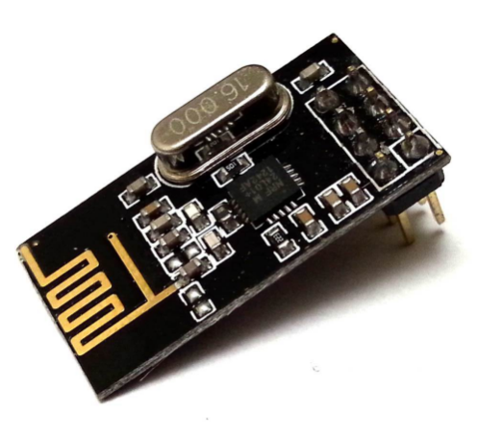

Figure : RF module nRF24L01+

The nRF24L01+ is a single chip 2.4GHz transceiver with an embedded baseband protocol engine (Enhanced ShockBurst™), suitable for ultra-low power wireless applications. The nRF24L01+ is designed for operation in the world wide ISM frequency band at 2.400 - 2.4835GHz.

This module will be used as the way for nodes and hub communicate with each other in our system. A car park is a very large area, meaning it have little to none obstructed object, so with a 2.4 GHz RF module, the system will have a longer range and a smaller antenna, meaning smaller size. This module also provides lots of other benefit such as multiple reading pipes, large payload packet… so it easy for us to implement a more complicated network model such as Tree, Mesh, Hop…

**PINOUT:**

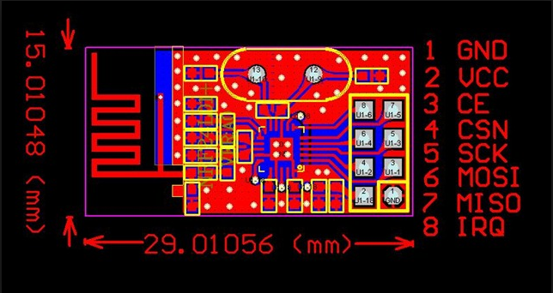

Figure : nRF24L01+ pinout

|  |  |  |  |
| --- | --- | --- | --- |
| **Pin** | **Name** | **Pin function** | **Description** |
| 1 | GND | Power | Ground (0V) |
| 2 | VCC | Power | Power Supply (+1.9V - +3.6V DC) |
| 3 | CE | Digital Input | Chip Enable Actives RX or TX mode |
| 4 | CSN | Digital Input | SPI Chip Select |
| 5 | SCK | Digital Input | SPI Clock |
| 6 | MOSI | Digital Input | SPI Slave Data Input |
| 7 | MISO | Digital Output | SPI Slave Data Output, with tri-state option |
| 8 | IRQ | Digital Output | Maskable interrupt pin. Active low. |

Table : nRF24L01+ pinout

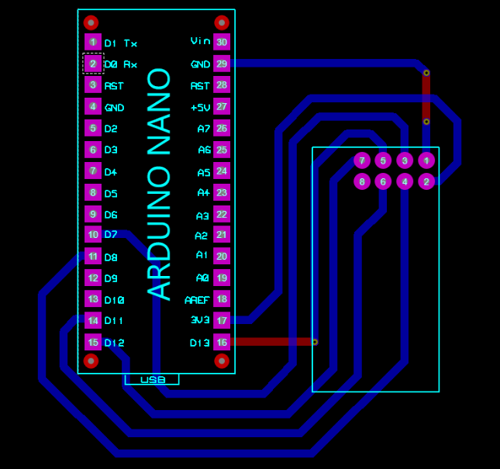

Figure : Arduino Nano and nRF24L01+ connection

**MODES OF OPERATION**

* **Power down mode:** In power down mode nRF24L01+ is disabled using minimal current consumption. All register values available are maintained and the SPI is kept active, enabling change of configuration and the uploading/downloading of data registers.
* **Standby-I mode:** By setting the PWR_UP bit in the CONFIG register to 1, the device enters standby-I mode. Standby-I mode is used to minimize average current consumption while maintaining short start up times. In this mode only part of the crystal oscillator is active. Change to active modes only happens if CE is set high and when CE is set low, the nRF24L01 returns to standby-I mode from both the TX and RX modes.
* **Standby-II mode:** In standby-II mode extra clock buffers are active and more current is used compared to standby-I mode. nRF24L01+ enters standby-II mode if CE is held high on a PTX device with an empty TX FIFO. If a new packet is uploaded to the TX FIFO, the PLL immediately starts and the packet is transmitted after the normal PLL settling delay (130µs).
* **RX mode:** The RX mode is an active mode where the nRF24L01+ radio is used as a receiver. To enter this mode, the nRF24L01+ must have the PWR_UP bit, PRIM_RX bit and the CE pin set high. In RX mode the receiver demodulates the signals from the RF channel, constantly presenting the demodulated data to the baseband protocol engine. The baseband protocol engine constantly searches for a valid packet. If a valid packet is found (by a matching address and a valid CRC) the payload of the packet is presented in a vacant slot in the RX FIFOs. If the RX FIFOs are full, the received packet is discarded.
* **TX mode:** The TX mode is an active mode for transmitting packets. To enter this mode, the nRF24L01+ must have the PWR_UP bit set high, PRIM_RX bit set low, a payload in the TX FIFO and a high pulse on the CE for more than 10µs. The nRF24L01+ stays in TX mode until it finishes transmitting a packet.

**PACKET FORMAT:**



Figure : nRF24L01+ packet format

* **Preamble:** The preamble is a bit sequence used to synchronize the receiver’s demodulator to the incoming bit stream. The preamble is one byte long and is either 01010101 or 10101010. If the first bit in the address is 1 the preamble is automatically set to 10101010 and if the first bit is 0 the preamble is automatically set to 01010101. This is done to ensure there are enough transitions in the preamble to stabilize the receiver.
* **Address:** This is the address for the receiver. An address ensures that the packet is detected and received by the correct receiver, preventing accidental cross talk between multiple nRF24L01+ systems.
* **Packet Control Field:** The packet control field contains a 6 bit **payload length** field, a 2 bit **PID** (Packet Identity) field and a 1 bit **NO_ACK flag**. **Payload length** specifies the length of the payload in bytes. **PID** is used to detect if the received packet is new or retransmitted. **NO_ACK flag** is only used when the auto acknowledgement feature is used.
* **Payload:** The payload is the user defined content of the packet. It can be 0 to 32 bytes wide and is transmitted on-air when it is uploaded to nRF24L01+.
* **CRC:** The CRC is the mandatory error detection mechanism in the packet. It is either 1 or 2 bytes and is calculated over the address, Packet Control Field and Payload.

**SPI COMMANDS**

|  |  |  |  |
| --- | --- | --- | --- |
| **Command name** | **Command** | **# Data bytes** | **Operation** |
| R_REGISTER | 000A AAAA | 1 to 5 LSByte first | Read command and status registers. AAAAA = 5 bit Register Map Address |
| W_REGISTER | 001A AAAA | 1 to 5 LSByte first | Write command and status registers. AAAAA = 5 bit Register Map Address Executable in power down or standby modes only. |
| R_RX_PAYLOAD | 0110 0001 | 1 to 32 LSByte first | Read RX-payload: 1 – 32 bytes. A read operation always starts at byte 0. Payload is deleted from FIFO after it is read. Used in RX mode. |
| W_TX_PAYLOAD | 1010 0000 | 1 to 32 LSByte first | Write TX-payload: 1 – 32 bytes. A write operation always starts at byte 0 used in TX payload. |
| FLUSH_TX | 1110 0001 | 0 | Flush TX FIFO, used in TX mode |
| FLUSH_RX | 1110 0010 | 0 | Flush RX FIFO, used in RX mode Should not be executed during transmission of acknowledge, that is, acknowledge package will not be completed. |
| REUSE_TX_PL | 1110 0011 | 0 | Used for a PTX device  Reuse last transmitted payload. TX payload reuse is active until W_TX_PAYLOAD or FLUSH TX is executed. TX payload reuse must not be activated or deactivated during package transmission. |
| R_RX_PL_WIDa | 0110 0000 | 1 | Read RX payload width for the top R_RX_PAYLOAD in the RX FIFO. |
| W_ACK_PAYLOADa | 1010 1PPP | 1 to 32 LSByte first | Used in RX mode. Write Payload to be transmitted together with ACK packet on PIPE PPP. (PPP valid in the range from 000 to 101). Maximum three ACK packet payloads can be pending. Payloads with same PPP are handled using first in - first out principle. Write payload: 1– 32 bytes. A write operation always starts at byte 0. |
| W_TX_PAYLOAD_NO ACKa | 1011 0000 | 1 to 32 LSByte first | Used in TX mode. Disables AUTOACK on this specific packet. |
| NOP | 1111 1111 | 0 | No Operation. Might be used to read the STATUS register |

Table : nRF24L01+ SPI commands

**IMPLEMENT:**

We implemented the usage of this magnetometer in C++ code in a module name rf_meta, which can be refer in previous section 4.3 for more information.

#### Lot node

##### RGB LED common anode

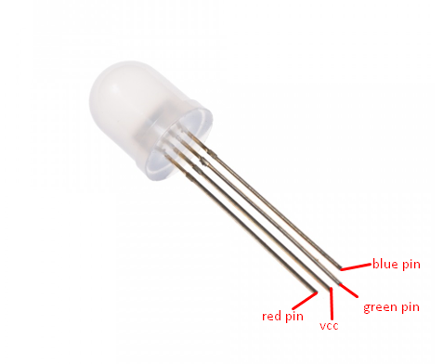

Figure : RGB LED common anode

RGB LED allows you to change the lights to any color to show state of parking slot.

In a real product environment, we will use led strip, but for current scope, in demo environment, we use a single RGB LED, which work in the same way as led strip, as an indicator for lot in the car park. The led will change color depended on the current status of the lot, for example, red if the lot is occupied and green if the lot is emptied.

**IMPLEMENT:**

We implemented the usage of this magnetometer in C++ code in a module name RF_META, which can be refer in previous section 4.3 for more information.

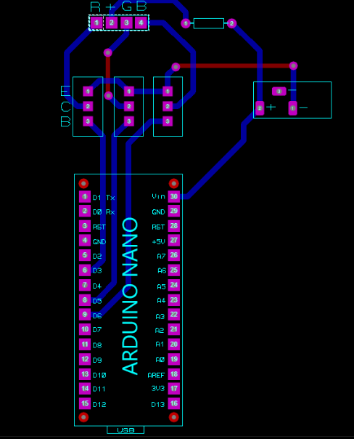

Figure : Arduino Nano and RGB LED connection through TIP122

##### Transistor TIP122



Figure : Transistor TIP122

A single digital pin on Arduino Nano do not provide enough current to power RGB LED, A solution for this situation is to use an NPN Darlington Transistor designed for medium power linear switching applications, so we use TIP122 Transistor to provide RGB LED with power from an external source. It can power devices up to 100VDC at 5 Amps.

**PINOUT:**



Figure : Transistor TIP122 pinout

##### Servo motor SG90



Figure : Servo motor SG90

In demo environment, we use the servo motor SG90 to control the model barrier in each parking lot. In default position, the servo will return to 0 value, and if the lot is reserved, or is disabled by manager, the servo will change value to 90 and the barrier will block any car try to enter that lot.

**PINOUT:**

|  |  |  |
| --- | --- | --- |
| **Pin of Servo SG90** | **Name** | **Description** |
| Red | VCC | Power supply 5V |
| Black | GND | Power supply ground |
| Yellow | Signal | The servo will move based on the signal sent to signal wire. |

Table : Servo motor SG90 pinout

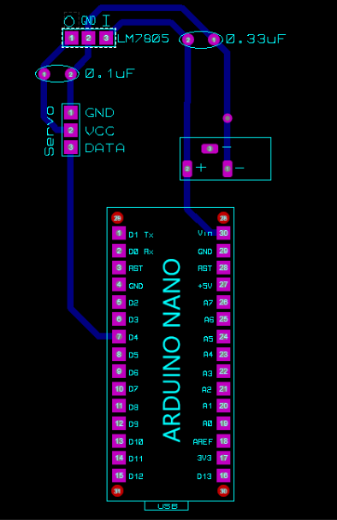

Figure : Arduino Nano and Servo SG90 connection, with LM7805

We connect this module to Arduino Nano with pin D4 and control it using the Servo library provided by Arduino.

##### LM7805

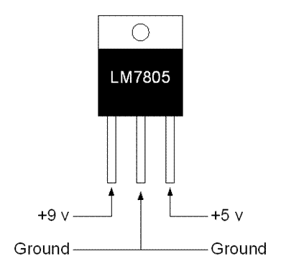

Figure : LM7805

Because the above servo SG90 operating voltage is 4.8V (~5V) so we need to connect it with this voltage regulator to make sure that the voltage provided from our Arduino Nano can be adjusted to eliminate noise and distribution problems associated with single-point regulation.

The connection of LM7805 with Arduino Nano can be seen in the above Figure 82.

#### Sign node

##### Power logic 8-bit shift register TPIC6B595



Figure : Power logic 8-bit shift register TPIC6B595

To display high power 7-segment display, we choose IC TPIC6B595 instead of IC 74HC595 because TPIC6B595 is asimple shift register IC that can control high-voltage/high-current devices directly**.** Each output pin can sink 150mA and then supports the maximum of Load Voltage at 50V.

**PINOUT:**



Figure : Power logic 8-bit shift register TPIC6B595 pinout

|  |  |  |  |
| --- | --- | --- | --- |
| **Pin** | | **I/O** | **Description** |
| **Name** | **No.** | O | Open-drain output |
| DRAIN0 | 4 |
| DRAIN1 | 5 |
| DRAIN2 | 6 |
| DRAIN3 | 7 |
| DRAIN4 | 14 |
| DRAIN5 | 15 |
| DRAIN6 | 16 |
| DRAIN7 | 17 |
| G | 9 | I | Output enable, active-low |
| GND | 10,11,19 | - | Power ground |
| NC | 1, 20 | - | No internal connection |
| RCK | 12 | I | Register clock |
| SERIN | 3 | I | Serial data input |
| SEROUT | 18 | O | Serial data output |
| SRCK | 15 | I | Shift register clock |
| SRCLR | 8 | I | Shift register clear, active-low |
| VCC | 2 | I | Power supply |

Table : Power logic 8-bit shift register TPIC6B595 pinout

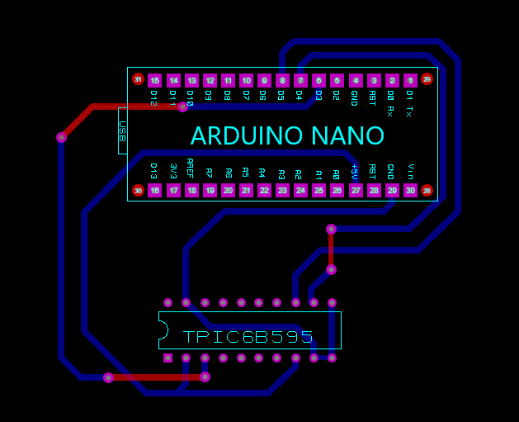

Figure : Arduino Nano and TPIC6B595 connection

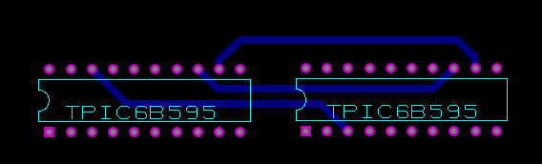

Figure : Sequence connection between 2 TPIC6B595

##### 7-Segment LED display

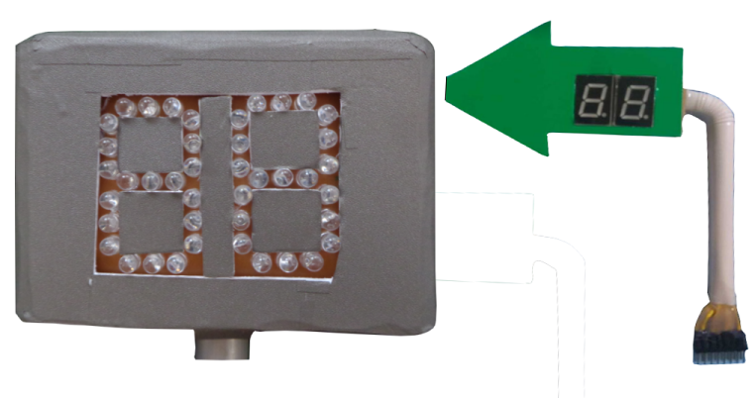

Figure : 7-Segment LED display

For demo sake, we use both rebuild 7-segment led and our custom created 7-segment led for sign nodes and main gate display board. All the 7-segment led used in our project is common anode.

The led in the sign nodes displays the available lots in their respected zone. The led in the main gate display board displays the total available lots of all the sign nodes.

The usage of these 7-segment led and the above shift register is implemented by us in a module name SEVEN_SEGMENT, which can be referred to in previous section 4.3 for more information.

#### Components connection

##### Overview component connection



Figure : General component connection



Figure : Lot node connection



Figure : Sign node connection

##### Raspberry Pi 3 connection

|  |  |
| --- | --- |
| **Rpi 3** | **NRF24L01+** |
| 25 – Ground | 1 – GND |
| 17 – 3v3 | 2 – VCC |
| 15 – GPIO22 | 3 – CE |
| 24 – GPIO8 | 4 – CSN |
| 23 – SCKL | 5 – SCK |
| 19 – MOSI | 6 – MOSI |
| 21 – MISO | 7 - MISO |

Table : Raspberry Pi 3 connection

##### Lot node connection

|  |  |  |  |  |
| --- | --- | --- | --- | --- |
| **Arduino Nano** | **HMC5883L** | **NRF24L01+** | **RGB LED** | **Servo** |
| 6 – D3 |  |  | Red pin  (through TIP122) |  |
| 7 – D4 |  |  |  | Data pin |
| 8 – D5 |  |  | Green pin  (through TIP122) |  |
| 9 – D6 |  |  | Blue pin  (through TIP122) |  |
| 10 – D7 |  | 3 – CE |  |  |
| 11 – D8 |  | 4 – CS |  |  |
| 14 – D11 |  | 6 – MOSI |  |  |
| 15 – D12 |  | 7 – MISO |  |  |
| 16 – D13 |  | 5 - SCK |  |  |
| 23 – A4 | 4 – SDA |  |  |  |
| 24 – A5 | 3 – SCL |  |  |  |

Table : Lot node connection

##### Sign node connection

|  |  |  |
| --- | --- | --- |
| **Arduino Nano** | **NRF24L01+** | **TPIC6B595** |
| 5V |  | 2 – VCC, 8 – SRCLR |
| Ground |  | 9, 10, 11 - GND |
| 6 – D3 |  | 3 – SER_IN |
| 7 – D4 |  | 12 – RCK |
| 8 – D5 |  | 13 - SRCK |
| 10 – D7 | 3 – CE |  |
| 11 – D8 | 4 – CS |  |
| 14 – D11 | 6 – MOSI |  |
| 15 – D15 | 7 – MISO |  |
| 16 – D13 | 5 - SCK |  |

Table : Sign node connection

|  |  |
| --- | --- |
| **TPIC6B595 (1)** | **TPIC6B595 (2)** |
| 12 – RCK | 12 – RCK |
| 13 – SRCK | 13 – SRCK |
| 18 – SER_OUT | 3 – SER_IN |

Table : TPIC6B595s sequence connection

## Interface

*References to main document, Section D – 5. Interface*

## Database Design

### Logical Diagram

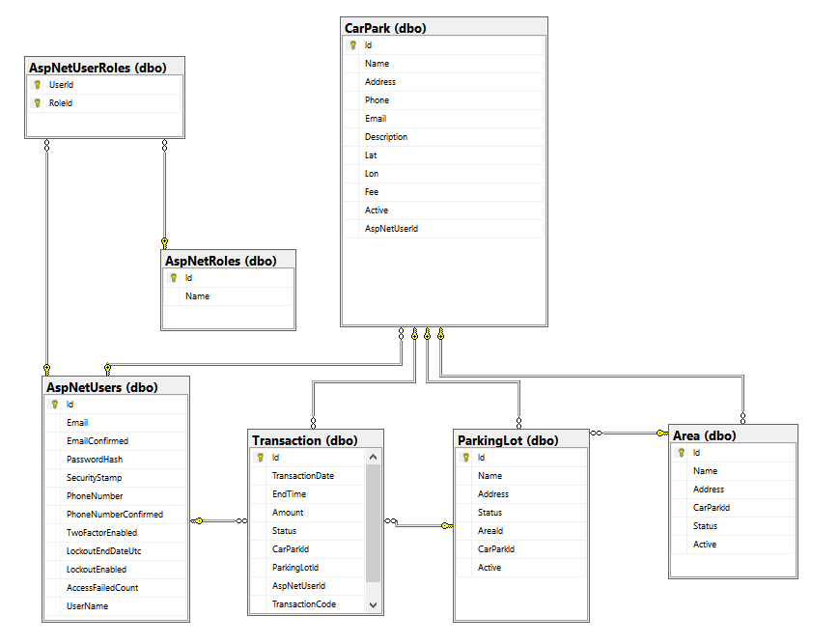

Figure : Database logical diagram

### Data Dictionary

|  |  |  |  |
| --- | --- | --- | --- |
| **Table Name** | **Column Name** | **Is Nullable** | **Data Type** |
| **Area** | Id | NO | int |
| Name | NO | nvarchar |
| Address | YES | int |
| CarParkId | NO | int |
| Status | NO | int |
| Active | NO | bit |
| **ParkingLot** | Id | NO | int |
| Name | NO | nvarchar |
| Address | NO | int |
| Status | NO | int |
| AreaId | YES | int |
| CarParkId | NO | int |
| Active | NO | bit |
| **Transaction** | Id | NO | int |
| TransactionDate | NO | datetime |
| EndTime | YES | datetime |
| Amount | NO | money |
| Status | NO | int |
| CarParkId | NO | int |
| ParkingLotId | NO | int |
| AspNetUserId | NO | nvarchar |
| TransactionCode | YES | nvarchar |
| **CarPark** | Id | NO | int |
| Name | NO | nvarchar |
| Address | NO | nvarchar |
| Phone | YES | nvarchar |
| Email | YES | nvarchar |
| Description | YES | nvarchar |
| Lat | NO | nvarchar |
| Lon | NO | nvarchar |
| Fee | YES | money |
| Active | NO | bit |
| AspNetUserId | YES | nvarchar |
| **AspNetRoles** | Id | NO | nvarchar |
| Name | NO | nvarchar |
| **AspNetUserRoles** | UserId | NO | nvarchar |
| RoleId | NO | nvarchar |
| **AspNetUsers** | Id | NO | nvarchar |
| Email | YES | nvarchar |
| EmailConfirmed | NO | bit |
| PasswordHash | YES | nvarchar |
| SecurityStamp | YES | nvarchar |
| PhoneNumber | YES | nvarchar |
| PhoneNumberConfirmed | NO | bit |
| TwoFactorEnabled | NO | bit |
| LockoutEndDateUtc | YES | datetime |
| LockoutEnabled | NO | bit |
| AccessFailedCount | NO | int |
| UserName | NO | nvarchar |

Table : Database data dictionary

## Algorithms

### GetDistance formula

To calculate the long distance with more accuracy, we must calculate the distance in the circle by using Haversine formula

$$hav\left(\frac{d}{r}\right)=hav\left(φ_{2}-φ_{1}\right)+\cos\left(φ_{1}\right)\cos\left(φ_{2}\right)hav(λ_{2}-λ_{1})$$

$hav$ is the haversine function

$$hav\left(θ\right)=\sin^{2}\left(\frac{θ}{2}\right)=\frac{1-\cos{(θ)}}{2}$$

*d* is the distance between the two points

*r* is the radius of the sphere,

*φ*1, *φ*2: latitude of point 1 and latitude of point 2, in radians

*λ*1, *λ*2: longitude of point 1 and longitude of point 2, in radians

By apply the inverse haversine or by using the arcsine, we can calculate d:

$$d=r.{hav}^{-1}\left(h\right)=2r.\arcsin\left(\sqrt{h}\right)$$

$$d=2r.arcsin⁡(\sqrt{hav\left(φ_{2}-φ_{1}\right)+\cos\left(φ_{1}\right)\cos\left(φ_{2}\right)hav\left(λ_{2}-λ_{1}\right)}$$

$$d=2r.arcsin⁡(\sqrt{\sin^{2}\left(\frac{φ_{2}-φ_{1}}{2}\right)+\cos\left(φ_{1}\right)\cos\left(φ_{2}\right)\sin^{2}(λ_{2}-λ_{1})}$$

### CRC Error Detection

#### Definition

The aim of an error detection technique is to enable the receiver of a message transmitted through a noisy (error-introducing) channel to determine whether the message has been corrupted. To do this, the transmitter constructs a value (called a checksum) that is a function of the message, and appends it to the message. The receiver can then use the same function to calculate the checksum of the received message and compare it with the appended checksum to see if the message was correctly received.

#### Define Problem

Because we do not require a license to operate radio equipment in the 2.4GHz band, as a result, other transmitter can broadcast on the same frequency that our devices use.

#### Solution theory

Two important aspects required to form a strong checksum function:

* **WIDTH:** a register width wide enough to provide a low a-priori probability of failure (e.g. 32-bits gives a 1/2^32 chance of failure).
* **CHAOS:** a formula that gives each input byte the potential to change any number of bits in the register.

For that reason, the CRC schemes use division with some changes so that if more bytes were added to the message, the checksum value could change radically again very quickly. All the arithmetic performed during CRC calculation is performed in binary with no carries, we will call it CRC arithmetic.

Adding two numbers in CRC arithmetic is the same as adding numbers in ordinary binary arithmetic except there is no carry. This means that each pair of corresponding bits determine the corresponding output bit without reference to any other bit positions. For example:

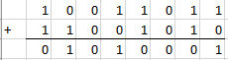

Figure : CRC arithmetic addition

Subtraction is identical:

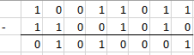

Figure : CRC arithmetic subtraction

In fact, both addition and subtraction in CRC arithmetic is equivalent to the XOR operation, and the XOR operation is its own inverse. This effectively reduces the operations of the first level of power (addition, subtraction) to a single operation that is its own inverse. This is a very convenient property of the arithmetic.

Having defined addition, we can move to multiplication and division. Multiplication is absolutely straightforward, being the sum of the first number, shifted in accordance with the second number. (note: the sum uses CRC addition)

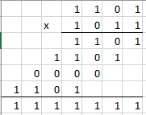

Figure : CRC arithmetic multiplication

Division is a little messier as we need to know when "a number goes into another number". To do this, we invoke the weak definition of magnitude defined earlier: that X is greater than or equal to Y if the position of the highest 1 bit of X is the same or greater than the position of the highest 1 bit of Y.

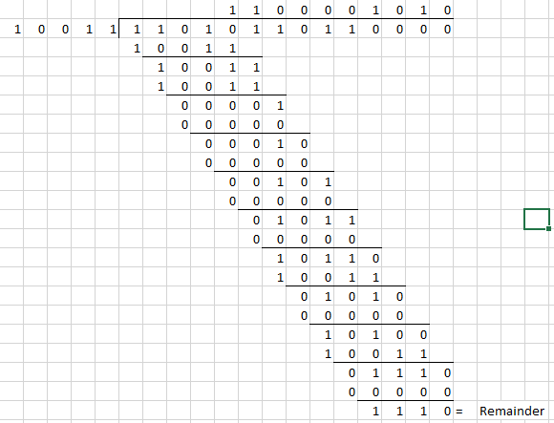

Figure : CRC arithmetic division

Having defined CRC arithmetic, we can now frame a CRC calculation as simply a division, because that's all it is. To perform a CRC calculation, we need to choose a divisor. In math marketing speak the divisor is called the "generator polynomial" or simply the "polynomial", and is a key parameter of any CRC algorithm. As a compromise, we will refer to the CRC polynomial as the "poly".

The width (position of the highest 1 bit) of the poly is very important as it dominates the whole calculation. Typically, widths of 16 or 32 are chosen so as to simplify implementation on modern computers. The width of a poly is the actual bit position of the highest bit. For example, the width of 10011 is 4, not 5. For the purposes of example, we will choose a poly of 10011 (of width W of 4).

Having chosen a poly, we can proceed with the calculation. This is simply a division (in CRC arithmetic) of the message by the poly. The only trick is that W zero bits are appended to the message before the CRC is calculated. Thus we have:

* Original message: 1101011011
* Poly: 10011
* Message after appending W zeros: 11010110110000

This is the same division as above figure, so we got the remainder, which is the calculated checksum is 1110. Usually, the checksum is then appended to the message and the result transmitted. In this case the transmission would be: 11010110111110. This ends the calculation.

A summary of the operation of the class of CRC algorithms:

* Choose a width W, and a poly G (of width W).
* Append W zero bits to the message. Call this M'.
* Divide M' by G using CRC arithmetic. The remainder is the checksum.

#### Implementation

To implement a CRC algorithm all we have to do is implement CRC division. There are two reasons why we cannot simply use the divide instruction of whatever machine we are on. The first is that we have to do the divide in CRC arithmetic. The second is that the dividend might be ten megabytes long, and todays processors do not have registers that big.

So to implement CRC division, we have to feed the message through a division register. At this point, we have to be absolutely precise about the message data. In all the following examples the message will be considered to be a stream of bytes (each of 8 bits) with bit 7 of each byte being considered to be the most significant bit (MSB). The bit stream formed from these bytes will be the bit stream with the MSB (bit 7) of the first byte first, going down to bit 0 of the first byte, and then the MSB of the second byte and so on.

For the purposes of example, consider a poly with W=4 and the poly=10111. Then, the perform the division, we need to use a 4-bit register:

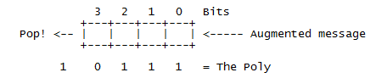

Figure : CRC implementation register

(Augmented message is the message followed by W zero bits)

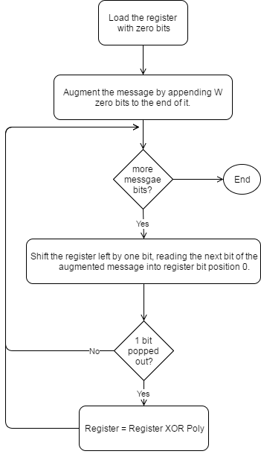

Figure : CRC implementation simple flow

#### Table-driven implementation

The implementation above is a good starting point because it corresponds directly to the theory presented so far, and because it is so simple. However, because it operates at the bit level, it is rather awkward to code (even in C), and inefficient to execute (it has to loop once for each bit). To speed it up, we need to find a way to enable the algorithm to process the message in units larger than one bit.

For the purposes of discussion, let us switch from a 4-bit poly to a 32-bit one. Our register looks much the same, except the boxes represent bytes instead of bits, and the Poly is 33 bits (one implicit 1 bit at the top and 32 "active" bits) (W=32).

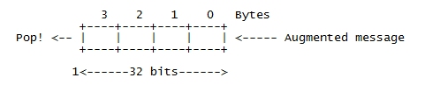

Figure : CRC 32-bits register

Consider for a moment that we use the top 8 bits of the register to calculate the value of the top bit of the register during the next 8 iterations. Suppose that we drive the next 8 iterations using the calculated values (which we could perhaps store in a single byte register and shift out to pick off each bit). Then we note three things:

* The top byte of the register now doesn't matter. No matter how many times and at what offset the poly is XORed to the top 8 bits, they will all be shifted out the right hand side during the next 8 iterations anyway.
* The remaining bits will be shifted left one position and the rightmost byte of the register will be shifted in the next byte.
* While all this is going on, the register will be subjected to a series of XOR's in accordance with the bits of the pre-calculated control byte.

Now consider the effect of XORing in a constant value at various offsets to a register. For example:

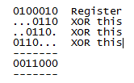

The point of this is that you can XOR constant values into a register to your heart's delight, and in the end, there will exist a value which when XORed in with the original register will have the same effect as all the other XORs.

Putting all the pieces together we have an algorithm that goes like this:

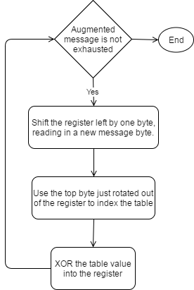

Figure : CRC implementation table-driven flow

For the actual implementation in project, we use 3 bytes in payload package as checksum, so we need to implement CRC24. Here is the table we use for CRC24 table-driven implementation:



Figure : CRC24 precomputed table

# E. System Implementation & Test

*References to main document, Section E. System Implementation & Test*

# F. User’s Manual

*References to main document, Section F. User’s Manual*

# G. Appendix

How to Connect a Voltage Regulator in a Circuit available at <http://www.learningaboutelectronics.com/Articles/How-to-connect-a-voltage-regulator-in-a-circuit>

Calculate distance from geo location available at <https://msdn.microsoft.com/en-us/library/system.device.location.geocoordinate.getdistanceto(v=vs.110).aspx>

Deriving the Haversine Formula available at <http://mathforum.org/library/drmath/view/51879.html>

Raspberry Pi 3 model B datasheet available at <https://www.raspberrypi.org/products/raspberry-pi-3-model-b/>

Arduino Board Nano information available at <https://www.arduino.cc/en/Main/arduinoBoardNano>

nRF24L01+ datasheet available at <https://www.sparkfun.com/datasheets/Components/SMD/nRF24L01Pluss_Preliminary_Product_Specification_v1_0.pdf>

HMC5883L 3-Axis Digital Compass datasheet available at <https://cdn-shop.adafruit.com/datasheets/HMC5883L_3-Axis_Digital_Compass_IC.pdf>

TPIC6b595 datasheet available at <http://www.ti.com/lit/ds/symlink/tpic6b595.pdf>

TIP122 datasheet available at <https://www.onsemi.com/pub/Collateral/TIP120-D.PDF>

Principles of communications networks and systems By Nevio Benvenuto and Michele Zorzi available at <http://as.wiley.com/WileyCDA/WileyTitle/productCd-0470744316.html>

A painless guide to CRC Error detection algorithms By Ross N. Williams available at <http://www.zlib.net/crc_v3.txt>

The Internet of Things: An Overview By Karen Rose, Scott Eldridge and Lyman Chapin available at <https://www.internetsociety.org/doc/iot-overview>